

EDUCATION YEAR 2nd TERM
www.egitimhane.com

1stENGLISH EXAMINATION FOR 4th GRADES
NAME-SURNAME: CLASS: 4/ A
NUMBER:

Mark:

A-)Cümleleri resimlere göre kutucuktaki kelimelerle eşleştiriniz. (2x5=10pts)
1.Water it 2. Plant it 3. Don’tcut it 4. Cut it 5. Do an experiment
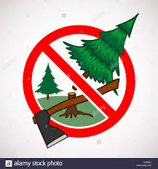


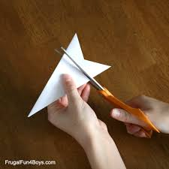

B-)Resimlerin altına uygun eylemleri yazınız.(2x5=10pts)
A-Climbing B-Riding a bike C-Fishing D-Playingfootball E-Reading comics

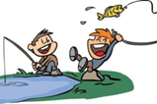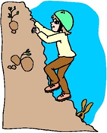

1___________ 2_____________ 3____________ 4____________ 5____________

C-)Aşağıdakikonuşmametninitamamlayınız.(4x5=20 pts)
1)Do youlikedancingandsinging?
A: …………………………………..?
B: I am a doctor.
A: …………………………………..?
B: I work at a hospital.
A: Whatdoes he do?
B: ……………………………….
A: …………………………………..?
B: She can dance.
A: …………………………………..?
B: Yes, I likesinginganddancing.
2 )What can she do?

3) What is yourjob?
4) Where do youwork?
5) He is a postman.
D-)Aşağıdakicümlelerieşleştiriniz.(4x5=20 pts)
He works at a policestation
Sheworks at a hospital
He works at a restaurant
Sheworks at a school
He works at a post office
5) Yusuf is a postman
4) Suna is a teacher
3) Ali is a chef
2) Ramazan is a policeman
- Derya is a nurse

E.Görseller ile bulundukları yerleri eşleştiriniz.(12P)
in -in front of - on - behind - under - near

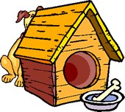

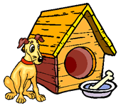
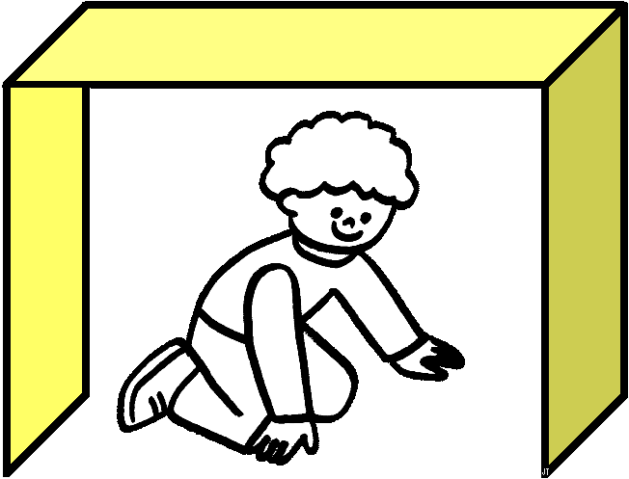


F.What time is it? Saatin kaç olduğunu yaz. ( 8P)
What time is it? | What time is it? | What time is it? | What time is it?
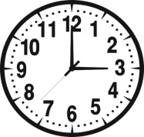 | 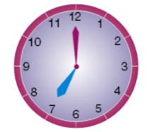 |  |  | 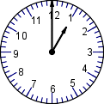
It’s………..o’clock. | ……………………….. | ……………………….. |  | ………………………..
H-)AşağıdakiifadeleriokuyupDoğru(True) veyaYanlış (False) yazınız.(4x5=20 pts)
- A doctorworks at theschool
- A farmerworks at a farm
- A singerworks at a musichall
- A vetlikeshelpinganimals
CEVAP ANAHTARI :YOUTUBE NURFER TAVŞANKORU

- A pilot plantsvegetables
TRUE / fALSE
TRUE / fALSE
TRUE / fALSE
TRUE / fALSE
TRUE / fALSE

