UNIT 9 ANIMAL SHELTER REVISION TEST
NAME – SURNAME:
CHOOSE THE CORRECT OPTION
1. ---------------
Cow /Sheep /Goat /Chicken . What is the best title?
a)Wild Animals b)Sea Animals c)Farm Animals d)Insects
2. We shouldn’t buy animals from pet shops. We should ------------ them from the shelters.
a) bark b)donate c) adopt d)fly
3.Put the words into the correct order to make a sentence.
feeding / she / the garden / is / the puppy / in .
1 2 3 4 5 6
a)3 – 4 – 5 – 1 – 2 – 6 b) 5 – 4 – 1 – 2 – 6 – 3 c) 4 – 1 – 2 – 3 – 6 – 5 d) 2 – 4 – 1 – 5 – 6 – 3
4. Which one is FALSE?
a)milk → the cow b) adopt → the lake c)drink → the milk d) go → to the zoo
5. Ahmet : ---------------------------?
Dad : No,you can’t. They are not hungry now.Maybe later.
a)Can I feed the sheep b)Can I walk the dog c)Can I take the birds d)Can I play with the puppies
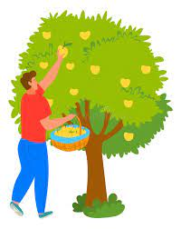
6. Alice: What are you doing grandpa?
Grandpa: ---------------------------
a)I’m cleaning the barn b)I’m picking the fruits
c)I’m collecting eggs d)I’m feeding the ducks
7.An elephant is ---------- than a lion.
a)big b) more big c)bigger d)the biggest
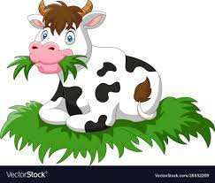
8. What is the cow doing?
a) It is eating grass. b) It is giving water.
c)It is flying. d) It is running fast
9.Where can you see these animals?
Shark/ Whale / Dolphin
a)on the tree b)In the Sea c)In the forest d)On the mountain
10.Mark: When can we go to the shelter?
Mom: ---------------------------
a)At the weekend b)At nine o’clock c)You can see puppies d)Let’s visit the zoo
11.Which animal doesn’t live in the farm?
a)Goat b)Sheep c)Wolf d)Horse
12.Which bird can talk like people?
a)Penguin b)Parrot c)Chicken d)Duck

13.Tom: How about going to the zoo today?
Mary: ------------------------------.In which option Mary ACCEPTS the offer?
a)I’m Sorry.I’m busy today b)That’s a bad idea.
c)I don’t like going to zoo d)Of course.What time shall we meet?
14.Look! There is a puppy under the tree.I think it’s ill.Let’s take it to the -------------
a)vet b)dentist c)farmer d)driver
15. Tony: ----------------------?
Jane: I’m eating a sandwich. Which one is the CORRECT question?
a)What are you drinking b)Where are you going
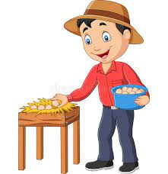
c)What do you have lunch d)What are you eating
16.What is the boy doing?
a)He is collecting eggs b)He is drinking water
c)He is eating eggs d)He is feeding the chicken
READ THE TEXT AND ANSWER THE QUESTIONS (17-18-19-20)
Hi! My name is Simon. These are my friends Brad, Kevin and Mary. We are at the animal shelter now.
We come here every weekend. There are lots animals such as dogs, cats, rabbits, turtles and
parrots. All of them are homeless and they are waiting for attention. Kevin is playing with the
kittens and Mary is feeding the puppies and their mom. The vet is examining a rabbit and Brad is
helping her. I’m cleaning the doghouse. We are having a great time here.
17. Which one is FALSE?
a)Simon is cleaning the doghouse. b) They are at the animal shelter.
c)Mary is helping the vet. d) Kevin is playing with the kittens
18. What is the vet doing now?
a)She is feeding the puppies. b)She is cleaning the animal shelter.
c)She is waiting for attention. d)She is examining a rabbit.
19. Which animal doesn’t live in this animal shelter?
a)dog b)turtle c)zebra d)parrot
20. How often do they go to the animal shelter?
a) In the garden. b) At the zoo. c) Every weekend. d) At half past four

GOOD LUCK!!

