2021-2022 EDUCATION TERM ÇELİK SANAYİ SECONDARY SCHOOL 2nd TERM 2nd WRITTEN EXAM for 7th GRADERS
Name,surname :
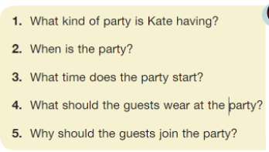
A.Read the invitation card and answer the questions.(20 p.)


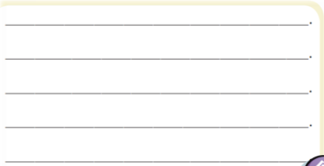
1.
2.
3.
4.
5.

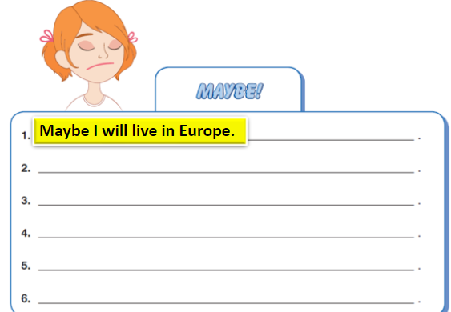
B.Write simple sentences about you as in the example.(20 p.)

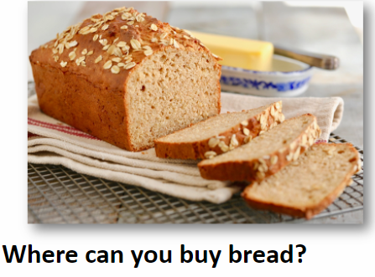

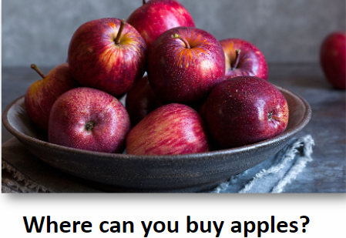
C.Answer the questions.(15 p.)

………………………………………… …………………………………… ………………………………….
D.Rewrite the sentences as in the example.(15 p.)
1.I went to bakery .I bought some cookies. I went to bakery to buy some cookies.
2.They go to department store.They can do shopping.
3.Melike will go to chemist’s.She will buy some medicines.
4.We go to an amusement park.We have fun.
5.Yunus went to coffee shop with his girlfriend.He drank something.
6.Hasne went to an art gallery.She saw some paintings.
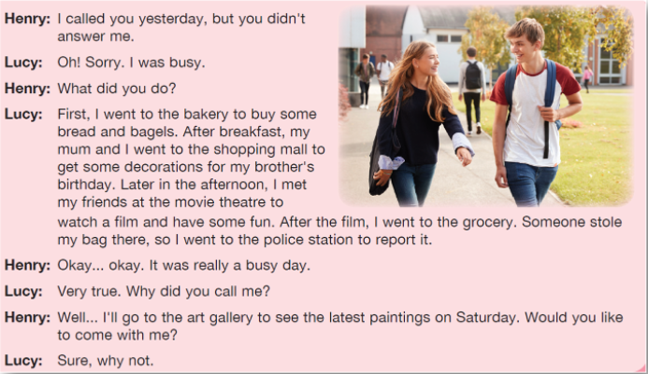
E. (15 p.)
1-………………………………..
2-………………………………..
3-……………………………….
4-……………………………….
5-……………………………….

F. (15 p.)
1-We should use public transportation.
2-………………………………………………………….
3-…………………………………………………………
4-…………………………………………………………
5-…………………………………………………………
6-…………………………………………………………




