2021-2022 EĞİTİM-ÖĞRETİM YILI SARUHANLI ALMIŞ-ŞENTÜRK M.T.A.L.
9. SINIFLAR İNGİLİZCE DERSİ 2. DÖNEM 1. YAZILI SINAVI AAA
Adı- Soyadı:
Sınıfı / Numarası:
Aldığı not:

- LISTENING: Metni dinleyerek cümlelerin sonuna “TRUE” veya “FALSE” yazınız. (5*3=15 P)
- He wants to go to Antalya ……………
- He would like to travel on the 6th of April …………
- He would like to travel on the 4th of April …………
- He asks for a one-way ticket ……………..
- The ticket costs 200 TL …………..

- Aşağıda verilen kelimeleri boşluklara doğru şekilde yerleştiriniz. (5*2=10 P)
spicy / delicious / healthy / sour / greasy

- I think Italian food is ………………………. Everybody loves it.
- Fruit and vegetables are …………………… They are good for you.
- I don’t like …………………….. food, so I never fry them.
- Lemon is a ……………… fruit and I use it a lot in salads.
- I don’t enjoy Indian food. They are ……………….. They use lots of curry.

- READING: Parçayı okuyarak soruları cevaplandırınız. (5*3=15 P)
Hi, my name is Camilla. I'm from Brazil. We usually have ham or cheese sandwiches at breakfast. We love eating tropical fruit, too. They are always fresh and juicy, aren't they? Lunch is normally the biggest meal of the day. We come together with our family at dinner. We usually have dinner late. Our national food is 'feijoada'. We make it from black beans, pork and beef and often serve it with some rice. In many restaurants, they only serve feijoada on Saturdays. It is delicious. Also, many Brazilians include lentils in a New Year's menu because they believe it increases one's good luck. You know Brazilians are crazy about coffee. They drink coffee all day-morning, noon and night because it is cheap ad healthy.
- Where is Camilla from? ………..
- What is their national food? ………….
- Why do Brazilians include lentils in a New Year’s menu? …………………….….
- What do they have for breakfast? ……………………….……..
- What do Brazilians drink all day? ……………………….….

- VOCABULARY: Aşağıdaki cümlelerin başına müşteri için C, garson için W yazınız. (5*2=10 P)
_____ Can we have the menu, please?
_____ Are you ready to order?
_____ Would you like something to drink?
_____ How much is the lunch?
_____ Can I have the bill, please?

- VOCABULARY: Aşağıda verilen kelimeleri resimlerin altına doğru şekilde yerleştiriniz. (10*1=10 p)
Tomb - seat belt - temple - check-in-desk - lighthouse
boarding pass - Gate - statue - baggage - passport
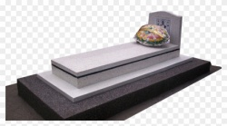 | 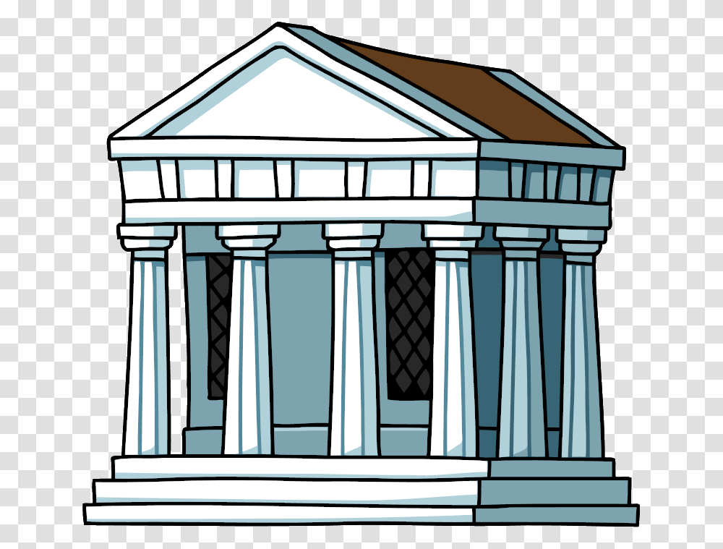 |  |  | 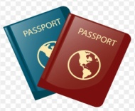
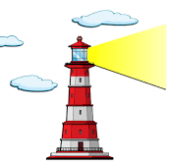 |  | 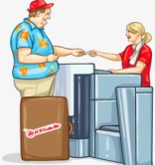 | 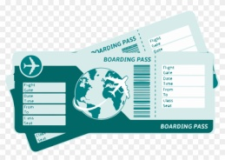 | 

- GRAMMAR: (10*3= 30 p)
- Parantez içinde verilen fiilleri geçmiş zaman yapısına uygun olarak boşluklara yazınız.
- The students ……………….. the museum last Monday. (visit, +)
- I ………………… English at college. (learn, +)
- Asuman ……………….. her father in the garden. (help, +)
- We …………………. breakfast all together this morning. (have, +)
- Cemil ……………….. to Ankara two weeks ago. (go, +)

- Boşlukları was, wasn’t, were, weren’t ile doldurunuz.
- I ………………… a lazy boy at high school. (+)
- You ………………… at home last night. Where were you? (-)
- Emre and İlayda …………….. very excited to see me. (+)
- It …………….. rainy and cold yesterday. (+)
- She …………….. a nurse five years ago. (-)

- SPEAKING: Aşağıda size verilen seçeneklerden biriyle ilgili en az 6-7 cümle kurunuz. (Bu bölüm sınavdan sonra sözlü olarak yapılacaktır. Her hangi bir şey yazmayınız) (10 puan)

- Geçen hafta sonu veya dün yaptıklarınızı anlatınız.
- Size gösterilen resimlerde olan olayları şimdiki zaman yapısıyla anlatınız.

Veysel DOĞANAY Canan ERSOY
İngilizce Öğretmeni İngilizce Öğretmeni

Rıza BAHAR
Okul Müdürü

9. sınıf 2. Dönem 1. Sınav LISTENING

Customer: Good morning. I would like to buy a ticket to Antalya, please.
Travel Agent: Sure, what is your name, please?
Customer: My name is Cemil Koparan.
Travel Agent: OK Mr Koparan. Which date would you like to travel?
Customer: On the sixth of April.
Travel Agent: Let me check! One way or round trip?
Customer: One way please. How much is the ticket?
Travel Agent: It’s four hundred liras.
Customer: OK, thank you. I’ll pay it by credit card.

