  - ACADEMIC YEAR AKTEPE ŞEHİT KÖKSAL KAŞALTI ANATOLIAN HIGH SCHOOL 1ST TERM 1ST EXAM FOR GRADES 9
GROUP B

A)Look at the family tree and complete the sentences.(6x3=18p) (Cümleleri aile ağacına bakarak cevaplayınız.)

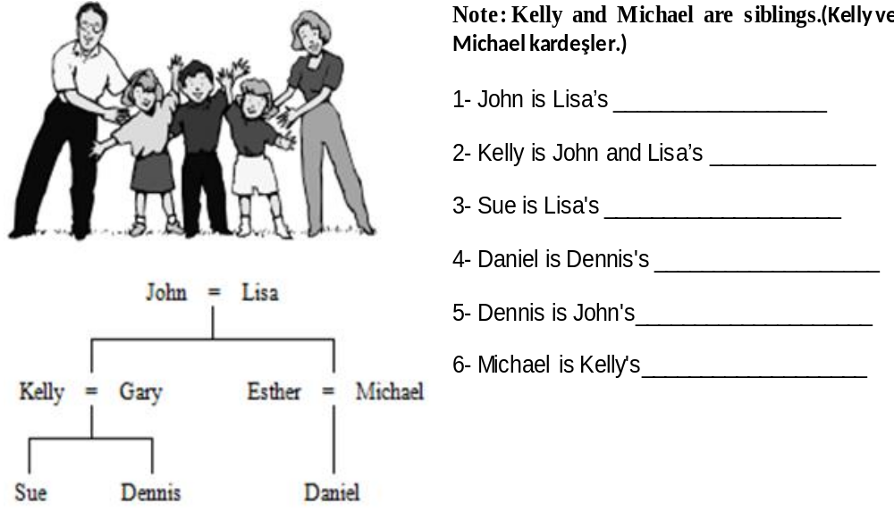
B) Fill in the blanks with the words from the box (Boşlukları kutudaki kelimelerden uygun olanı ile doldurunuz) (5x3=15 p)
Kill two birds with one stone - instructor - student ID card -
gorgeous – make yourself at home

1.The pyramids are one of the ____________________________ structures in the world.
2. Welcome, John;________________________________ , you can have anything you want. The fridge is there.
3.This city is lively and the people are very friendly. You can go dancing and making friends___________
________________!It’s great.
4.My driving ______________________________ says I should be more patient and slow.
5. She lost her _______________________________. So,she had to pay more money to enter the school.
C) Answer the Questions.(2x6=12p) (Soruları cevaplayınız.)
1.Do you want to live in a big or a small city?( Which one do you think is pretty?) Explain your ideas at least 2 sentences. ( En az 2 cümleyle düşüncelerinizi açıklayın.) (2x3=6p)
_
_
2.What type of room is your favourite? (Simple or complicated, warm colours or soft colours? )Explain your ideas at least 2 sentences. (En az 2 cümleyle düşüncelerinizi açıklayın. ) (2x3=6p)
_
_

D) Look at the Map and Answer the Questıons.(19p) (Haritaya bakınız ve soruları cevaplayınız.)
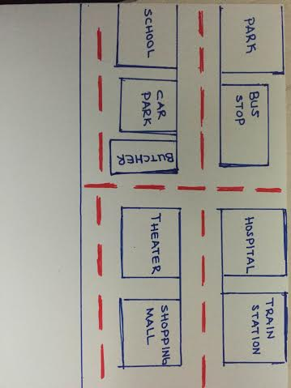
1. A: Excuse me! How can I get to the shopping mall?
B:Go along the Street and ______________, it is on your__________. (6p)

2. A: Excuse me! ……………………………………….
B: Go along this road, cross the Street, go past the hospital, it is on your right. (4p)

3.The hospital is ______________ the train station. (3p)

4. The shopping mall is _______________ the train station.(3p)

5. The car park is ________________ the bookstore and the school.(3p)

I’m here.
hospital
museum
bookstore
https://www.sorubak.com

E) Answer the questions according to the passage. (3x4=12p) (Parçaya göre soruları cevaplayınız.)
This is Patrick's family. He is 62.He is a retired teacher.He is married to Sally.Sally is a housewife.She is 57 years old.They have got only one son.His name is Micheal. His wife's name is Carole. She is a dentist. They have got one daughter and a son. Their daughter's name is Elizabeth and their son's name is Arnold. They are both students at primary school. Their dog's name is Max.

1.What is Patrick's job?...............................................................................................
2.How old is Sally?.......................................................................................................
3.What is the name of Micheal's wife?.......................................................................

F) Look at the Picture and fill in the blanks with correct prepositions and “there is/there are- on- in- opposite- behind- next to- in front of- under- between “(Tırnak içindeki kelimelerden uygun olanlarla boşlukları doldurunuz.)(8x3=24p)
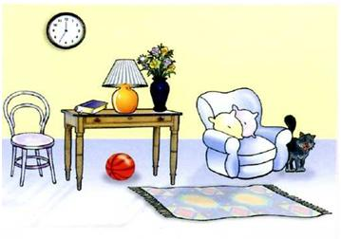
1._____________a ball ------------the table.

2._____________a chair ________
the table.

3.____________flowers ________
the vase.

4. ___________a carpet_________
the floor.

GOOD LUCK!

English Language Teacher
Esra ÜLKÜ EKE Muzaffer CANBULUT Principal

