2020-2021 EDUCATION YEAR CENGİZ TOPEL SECONDARY SCHOOL


5th GRADES 2nd TERM 1st OPTIONAL ENGLISH EXAM
NAME & SURNAME: No:

- Match the pictures with the illnesses. (Resimleri hastalıklar ile eşleştir.)(36 points)

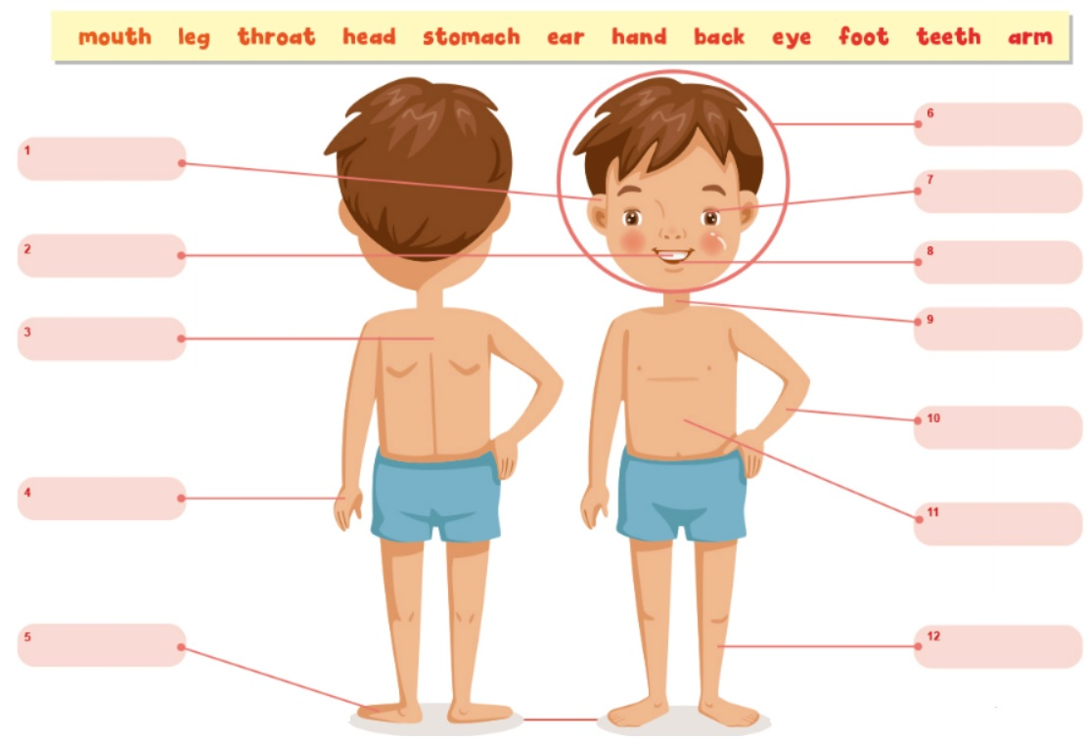

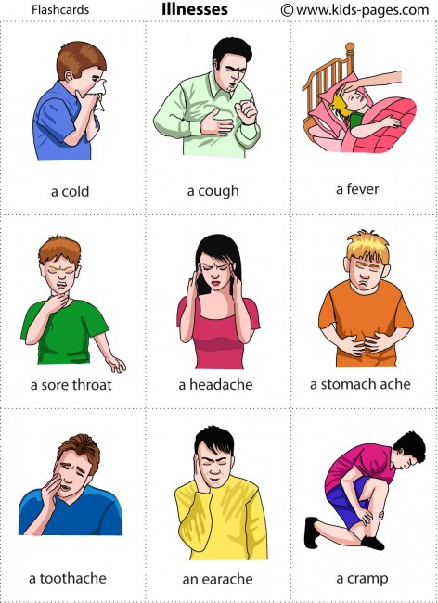
- Match the pictures with the illnesses. (Resimleri hastalıklar ile eşleştir.) (18 points)

- sore throat
- cough
- headache
- flu
- stomachache
- toothache

- Match the pictures with the movie types. (Resimleri film türleriyle eşleştir.)(16 points)
documentary - animation - romance - horror - action



……………………… ……………………… ……………………… ………………………

- Match the words with the pictures. (Kelimeleri resimlerle eşleştir.) (20 points)
strong - boring - funny - ugly - beautiful



- Circle the odd one. (Farklı olanı yuvarlak içine al.) (10 points)

- science fiction / western / comedy / about

- strong / musical / friendly / old

- boring / ugly / helpful / lazy

- dislike / love / hate / don’t like

- interesting / funny / adventure / young

Good luck!
Erkan TOY – Teacher of English

