1. ÜNİTE HELLO!
Unit Questions (Ünite Soruları)
Which classes do you have on Monday? Pazartesi günü hangi derslerin var?
How many classes do you have a week? Bir haftada kaç dersin var?
What is your favorite class? En sevdiğin ders ne?
Is your social studies class on Tuesday? Sosyal Bilgiler dersin Salı günü mü?
How many languages do you speak? Kaç dil konuşuyorsun?
Does she like music? O müziği sever mi?
How are you doing? Nasılsın? / Nasıl gidiyor?
Where do you study? Nerede öğrenim görüyorsun?
Where are you from? Nerelisin?
What nationality is she? O hangi ırktan? / Onun uyruğu ne?
Where does Marta live? Marta nerede yaşıyor?
How old are you? Kaç yaşındasın?

Common Expressions (Yaygın İfadeler)
Nice/ Glad to meet you. Tanıştığıma memnun oldum.
My favorite class is maths. En sevdiğim ders matematik.
I don’t like science. Fen Bilimlerini sevmem.
Naomi hates art classes. Naomi resim derslerinden nefret eder.
I speak English and German. İngilizce ve Almanca konuşurum.
She is a primary school student. O bir ilkokul öğrencisidir.
I’m in the 5th grade. Ben 5.sınıftayım.
I love drawing pictures. Resim çizmeyi severim.
See you at school. Okulda görüşürüz.
He enjoys doing experiments. O deney yapmayı sever.
I love art, but I don’t like science. Resim dersini severim ama fen bilimlerini sevmem.
She is from Canada. O Kanadalı.
I’m good at solving problems. Problem çözme konusunda iyiyim.

Vocabulary Lists
School Subjects (Okul Dersleri)
math(s) matematik
social studies sosyal bilgiler
art resim
geography coğrafya
physical education (P.E.) beden eğitimi
English İngilizce
history tarih
science fen bilimleri
Turkish Türkçe
music müzik
drama drama, oyun, piyes
physics fizik

Countries / Nationalities / Languages (Ülkeler / Irklar / Diller)

Turkey / Turkish Türkiye / Türk - Türkçe
England / English İngiltere / İngiliz - İngilizce
France / French Fransa / Fransız - Fransızca
Germany / German Almanya / Alman - Almanca
Britain / British Britanya / Britanyalı - İngiliz
Italy / Italian İtalya / İtalyan - İtalyanca
Spain / Spanish İspanya / İspanyol / İspanyolca
Canada / Canadian Kanada / Kanadalı
America / American Amerika / Amerikalı
China / Chinese Çin / Çinli - Çince
Japan / Japanese Japonya / Japon - Japonca
Russia / Russian Rusya / Rus – Rusça
Brazil / Brazilian Brezilya / Brezilyalı

Activities (Aktiviteler / Etkinlikler)
do experiments deney yapmak
swim yüzmek
play the guitar gitar çalmak
watch TV TV izlemek
read a book kitap okumak
play table tennis tenis oynamak
do puzzles yapboz yapmak
ride a horse ata binmek
climb tırmanmak
play chess satranç oynamak
solve problems problem çözmek
draw pictures resim çizmek
paint boyamak, resim yapmak
sing şarkı söylemek

Nouns (İsimler)
country ülke
nationality milliyet / ırk
course ders
language dil
child / children çocuk / çocuklar
map harita
age yaş
letter mektup
pleasure zevk, keyif
friend arkadaş

family aile
class sınıf
student öğrenci
week hafta
weekend hafta sonu
puppet kukla
chant şarkı, şarkı söylemek
information bilgi
timetable çizelge, ders programı
chart çizelge, tablo
Others (Diğerleri)
easy kolay primary school ilkokul
fun eğlenceli secondary school ortaokul
loud yüksek sesli elementary school ilköğretim okulu
far uzak high school lise
similar benzer language class dil dersi
speech bubble konuşma balonu
Days of the Week (Haftanın Günleri)
Monday Pazartesi
Tuesday Salı
Wednesday Çarşamba
Thursday Perşembe
Friday Cuma
Saturday Cumartesi
Sunday Pazar



Flags
England Italy
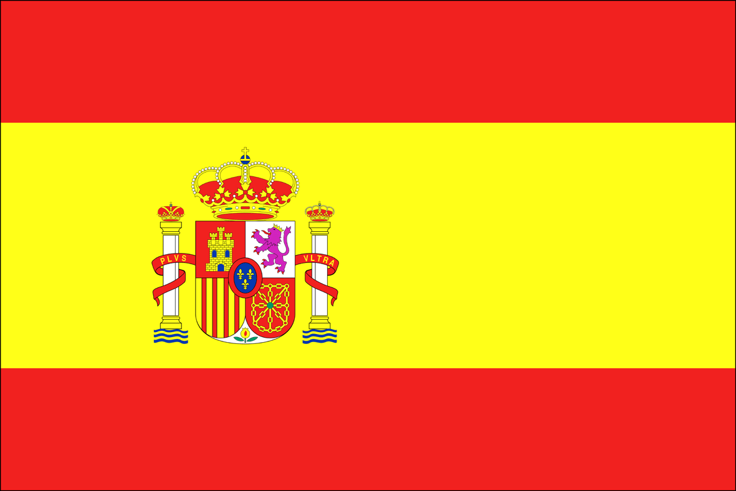

France Spain
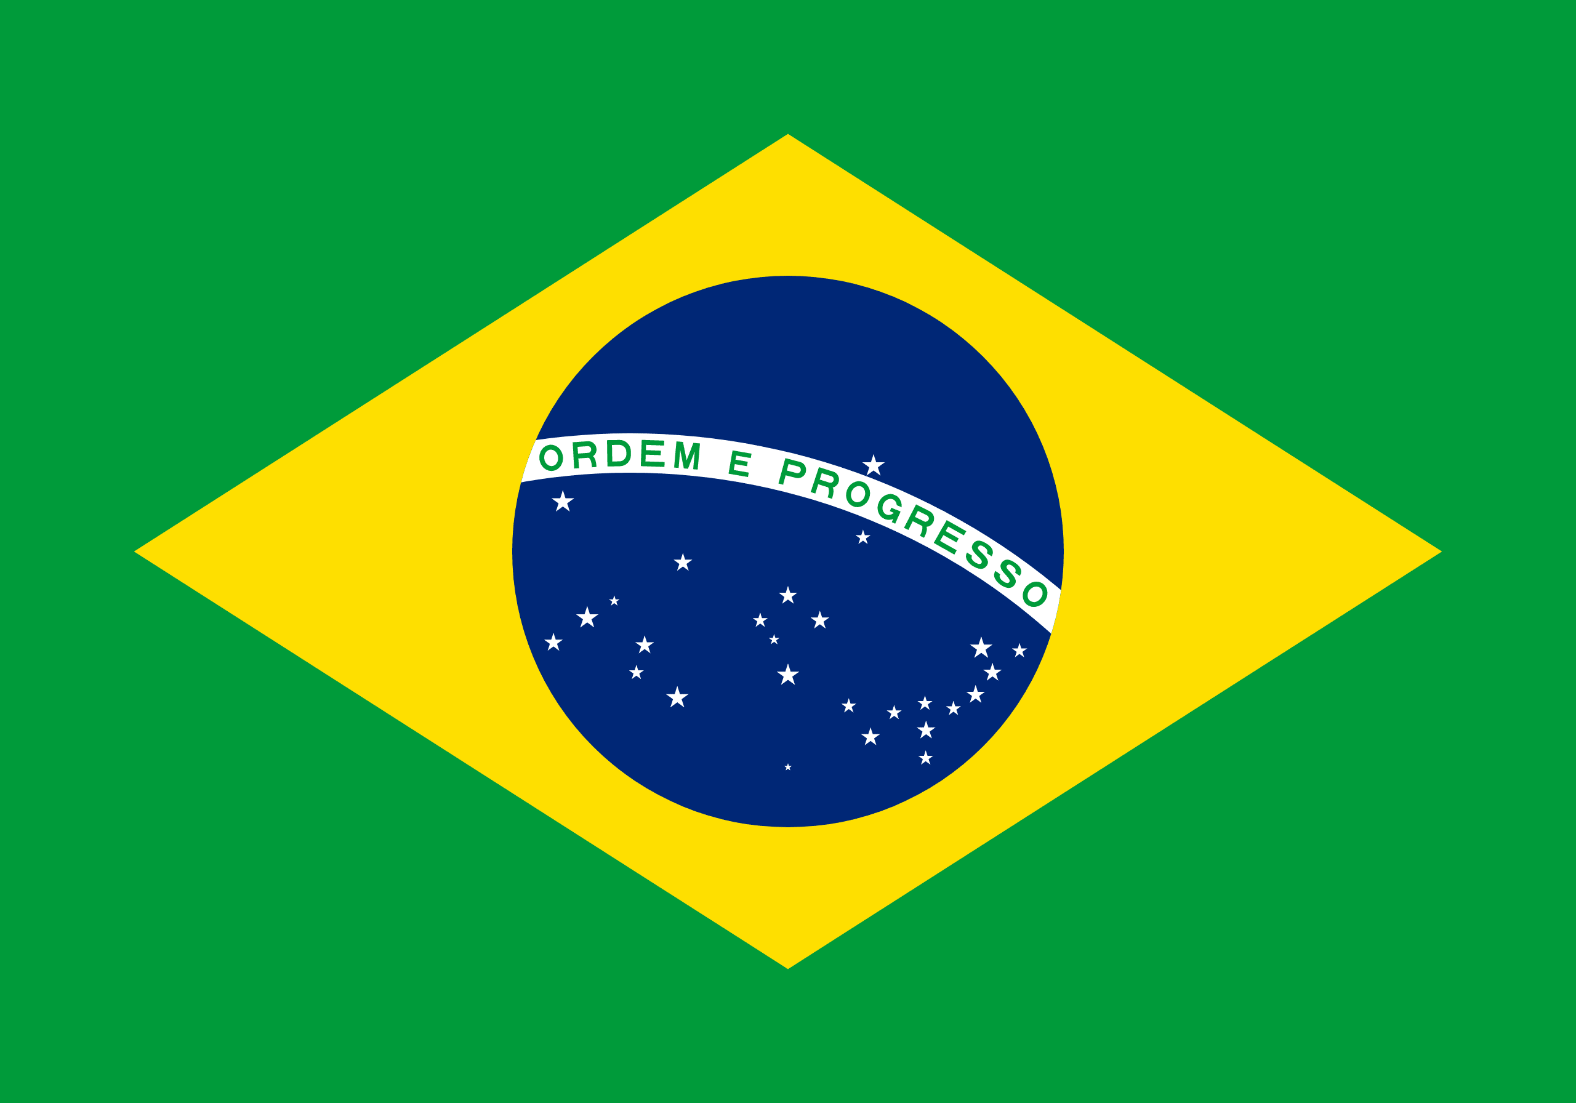

Germany Brazil

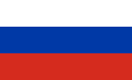

Canada Russia

China

Japan

Vocabulary Exercises
1. Fill in the blanks with the words below.
nationality languages live drawing
speak solving classes experiments
1. What _______ are you?
2. I can _______ three _______: They are German, French and English.
3. I am good at _______ pictures. My favorite lesson is art.
4. How many _______ do you have a week?
5. Mathilda likes science because she enjoys doing _______ .
6. A : Where do you _______ ?
B : In Paris.
7. Betty likes _______ problems. She is good at maths.

2. Circle the correct option in each sentence.
1. A : What nationality are you?
B : I am Canadian / from Canada.
2. I like doing / reading puzzles.
3. Helen’s favorite lesson is physic / physical education.
4. He loves music because he is good at painting / singing.
5. Paloma is from France / French. She is France / French.
6. Emma is in the 8th grade. She is a primary / secondary school student.
7. I speak China / Chinese and Japan / Japanese.
3. Match the pairs.
1. social ( ) bubble
2. read ( ) a horse
3. ride ( ) studies
4. play ( ) the guitar
5. language ( ) a book
6. speech ( ) class
4. Solve the puzzle with the days of the week.
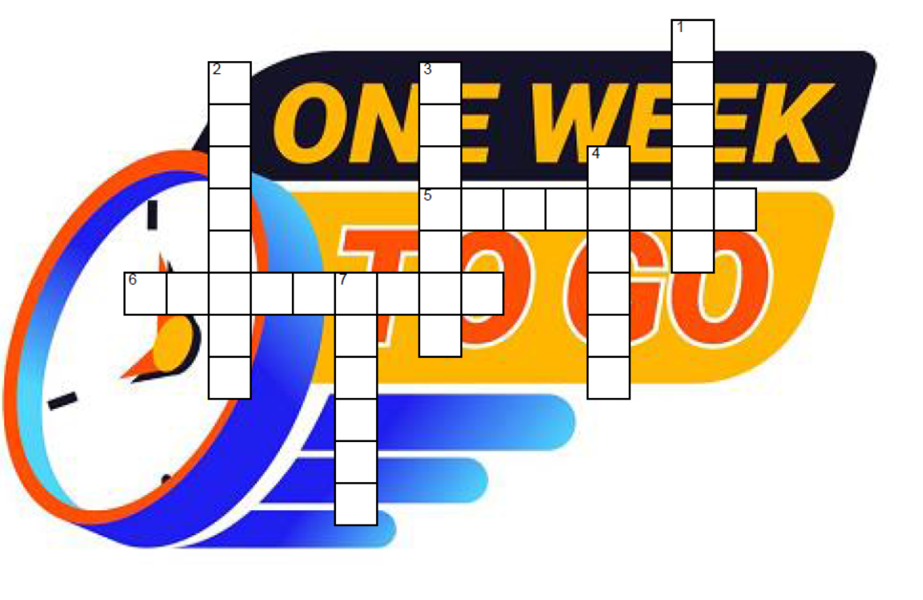
H
T
IO
E
U
O
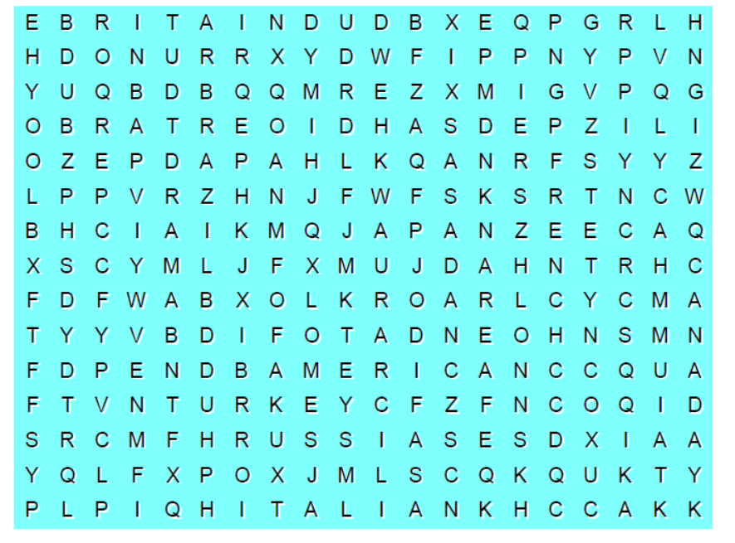
5. Search and find 10 words in the puzzle.

GRAMMAR
Likes & Dislikes
Positive | Negative | Question
I  We like maths.  You  They | I  We don’t like art.  You  They | I  Do we like drama?  you  they
He  She likes singing.  It | He  She doesn’t like music.  It | he  Does she like history?  it
Short Answers
Yes, I do. / No, I don’t.
Yes, we do. / No, we don’t.
Yes, you do. / No, you don’t.
Yes, they do. / No, they don’t.
Yes, he does. / No, he doesn’t.
Yes, she does. / No, she doesn’t.
Yes, it does. / No, it doesn’t.

GRAMMAR EXERCISE
Use the correct forms to complete the sentences according to the table below.
like dislike love hate
Classes | Luna | Harry | Ron | Mia
Science
History
P.E.
Art

1. Luna and Harry _______ history.
2. Ron and Mia _______ art.
3. Mia _______ science and art.
4. Harry _______ P.E .

5. Luna _______ art, but she _______ P.E.
6. Ron _______ history and art.
7. Harry _______ science, but Ron _______ it.
8. Mia _______ P.E but Luna _______ it.

NARTEST İNGİLİZCE KALİTESİNE DAHA FAZLA ULAŞMAK İÇİN

www.altinkarne.com Sitemizden Kitaplarımızın PDF hallerine, Akıllı Tahta Kitaplarımıza ve Ücretsiz Birçok Dokümana Ulaşabilirsiniz.

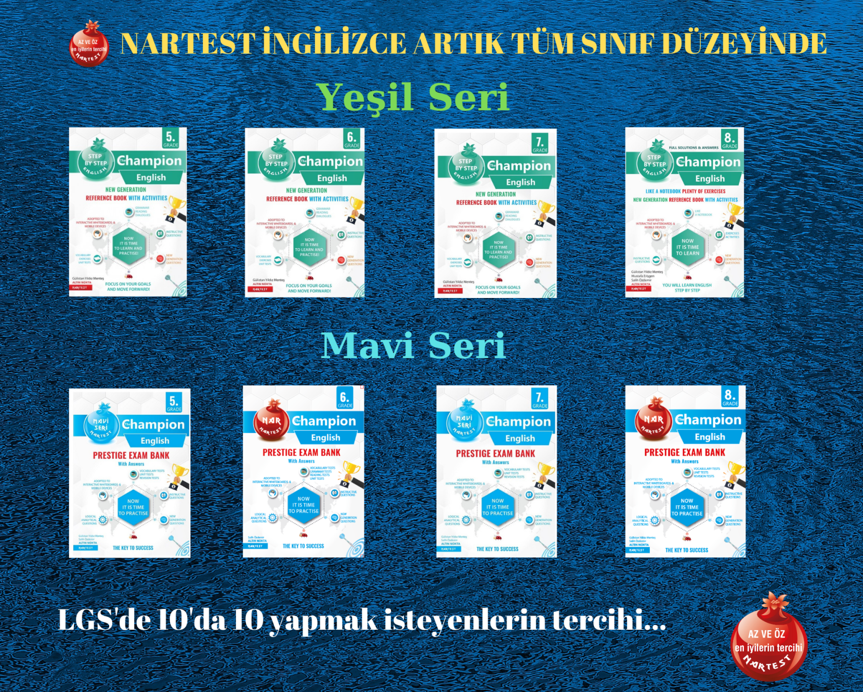

ANSWER KEY
Vocabulary Exercises

Exercise 1
1. nationality
2. speak / languages
3. drawing
4. classes
5. experiments
6. live
7. solving
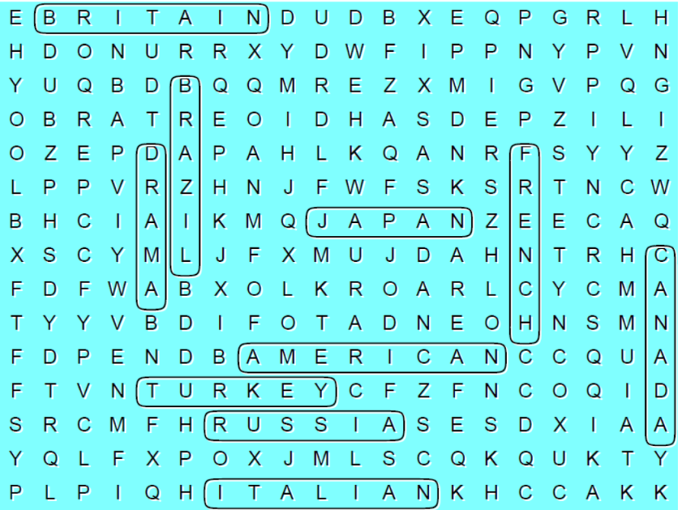
Exercise 2
1. Canadian
2. doing
3. physical
4. singing
5. France / French
6. secondary
7. Chinese / Japanese

Exercise 3
6 / 3 / 1 / 4 / 2 / 5

Exercise 4
1. MONDAY
2. THURSDAY
3. TUESDAY
4. FRIDAY
5. SATURDAY
6. WEDNESDAY
7. SUNDAY
Exercise 5
Grammar Exercise
1. like 5. loves / dislikes
2. dislike 6. dislikes
3. dislikes 7. loves / hates
4. hates 8. likes / dislikes

