TAVŞANCIL ZİYA TOPLAN SECONDARY SCHOOL FIRST TERM /FIRST WRITTEN EXAM 5TH GRADE Name : Surname :
1) Introduce yourself. (Kendinizi tanıtın.) (14 pts.)
-----------------------------------------------------------------------------------------------------------------------------------------------------------------------------------------------------------------------------------------------------------------------------------------------------------------------------------------------------------------------------------------------------------------------------------------------------------------------------------------------------------------------------------------------------------------------------------------------------------------------------------------------------------------------------------------------------------------------------------------------
2)MATCH THE QUESTIONS WITH THEIR ANSWERS. (SORULARLA CEVAPLARI EŞLEŞTİRİNİZ.)(10 PTS)
1. What is your name? ………………… I am eleven years old.
2. Where are you from? ………………… I am English.
3. What nationality are you? ………………… My name is Hamdi.
4. How old are you? ……………….. I am from Germany
5. How are you? ……………….. Fine, thanks and you.

3) COMPLETE THE TABLE ACCORDING TO THE SPEECH BUBBLE. (TABLOYU PARÇAYA GÖRE TAMAMLAYINIZ) (16 PTS)
Name:
Age:
Country:
Nationality:
Languages:
Favourite lessons:
Likes:
Dislikes:

Hello!
My name is Alfred. I am 13 years old. I am from Germany and I am German. I speak English and German languages. My favourite lessons are Music and P.E. He likes Music and P.E. but he doesn’t like Maths class.

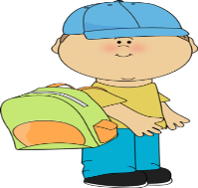

4) WRITE THE NATIONALITIES. (ÜLKELERİN MİLLETLERİNİ YAZ ) (15 PTS)
Country | Nationality
1)Turkey | _____
2) Spain | _____
3) France | _____
4) Germany | _____
5) Italy | _____
6) England | _____
7) Japan | _____

- Answer the questions according to timetable.( Soruları ders programına göre cevapla ) (20 pts)
Monday | Music | Maths | Maths | Art | Art
Tuesday | English 😊 | English 😊 | Music | I.T. | I.T
Wednesday | Turkish | Turkish | Science | Science | Music
Thursday | Social Studies | Social Studies | Religion | Religion | English 😊
Friday | p. E. | p.E | Science | Science | Maths
- When is your Art class?

- Do you have English on Monday?

- Which classes do you have on Friday?

- What is your favourite class?
7) MATCH THE PICTURES WITH THEIR NAMES. (10 PTS)
Library - swimming pool - hospital - bakery - pharmacy
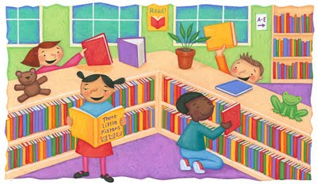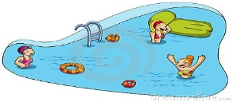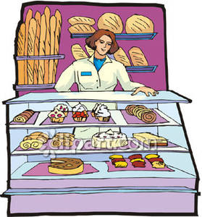
………………………. ……………………. ……………………. …………………….. ……………………………
Physical education - Science - Social studies - English - Art
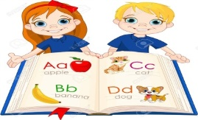
…………….. ………………… …………………… ………………….. ………………………..
8 ) LOOK AT THE MAP, FOLLOW THE DIRECTİONS AND FIND THE PLACES. (HARİTAYA BAKARAK TARİFE GÖRE GİTMENİZ GEREKEN YER İSMİNİ BOŞLUĞA YAZINIZ.) (15 PTS)
- Go straight ahead. Turn left into the Gazi Street. It is next to the café: _____________________

- Go along Bağdat Street.Turn right into the Gazi Street. It is opposite the bus station: _________

- Go along Bağdat Street. It’s behind supermarket___________

- Go straight ahead. Turn right into İstiklal Street. It’s on your left ____________________

- Go straight ahead and turn right into Gazi Street. It’s opposite the hospital ________________________

