2018-2019 EDUCATION YEAR RECAI KUTAN SECONDARY SCHOOL 1ST TERM 1ST EXAM FOR 8TH GRADES
NAME: SURNAME: NUMBER: CLASS:
A) GROUP THE VOCABULARY AS NEGATIVE AND POSITIVE (20X1=20 PTS)
honest-jealous-understanding-tactful-sneaky-generous-self centered-caring-fair-loyal-bad tempered-mean-aggressive-adventurous-arrogant-helpful-unreliable-stubborn-amusing-determined

POSITIVE | NEGATIVE
B) ANSWER THE QUESTIONS ABOUT YOURSELF (5x2=10 pts)
1. What time do you get up? ...............................................................................................................................
2. What kind of music do you like?........................................................................................................................
3. How do you go to school?.................................................................................................................................
4. How often do you go to the cinema?.................................................................................................................
5. Where do you have your lunch on weekdays?...................................................................................................
C)ANSWER THE QUESTION ACCORDING TO THE POSTER (4x2=8 pts)

1. What is the event?
......................................................................
2. What is the deadline to inform the organizers?
.......................................................................
3. How much is the fee for attending the event?
.........................................................................
4. Can parents join the event?
........................................................................

D) GROUP THE EXPRESSIONS (ifadeleri gruplandırın)(10X2=20 PTS)
1. That sounds awesome! 6. Shall we go for a picnic nxt Sunday?
2. I'll be definitely there. 7. Thanks but I don't get on well with James.
3. How about buying a birthday present? 8. I'm afraid I can't make it.
4. I'd like to but I have another plan. 9. Why don't you join us?
5. Would you like to come to my summer party? 10. Why not? It's a great idea.
INVITATION | ACCEPT | REFUSE

E)FILL IN THE BLANKS WITH ''ME TOO'' OR ''ME NEITHER'' (2 PTS)
1. AYLA: I watched this movie many times, it was amazing. 2. ARZU: I don't like crowded places.
DEMET: ............................................................... OYA : .....................................................
F) PUT THE FOOD VOCABULARY IN THE CORRECT PLACE ON THE MENU (6 pts)

MENU
MENU
Apple Pie
Lentil Soup
Lasagna Orange Juice
Today's Soup
Cake Lemonade
Grilled Chicken
SOUPS
...............................
..............................
MAIN COURSE
.............................
.............................
DESSERT
.............................
.............................
BEVERAGES
..............................
..............................

G)REPORT THE PARAGRAPH AGAIN (Paragrafı aktarın) (8 pts)
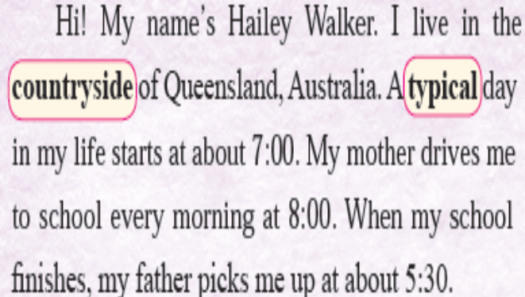

..................................................................................................................................................................................................................................................................................................................................................................................................................................................................................................................................................................................................................................................................................................................................................................................................................................................................................................................................................

H) Fill in the blanks with words and phrases from the box below. (5x2=10)
Let’s Shall Would you How about Why don’t
1 ....................................... we meet at 6 o’clock at the café?
2 ....................................... you visit the doctor?
3 ....................................... watch the soccer match tonight.
4 ....................................... like some fries with your burger?
5 ....................................... going out of the own next weekend?
I) COMPLETE THE BLANKS WITH THE SENTENCES BELOW (4 PTS)
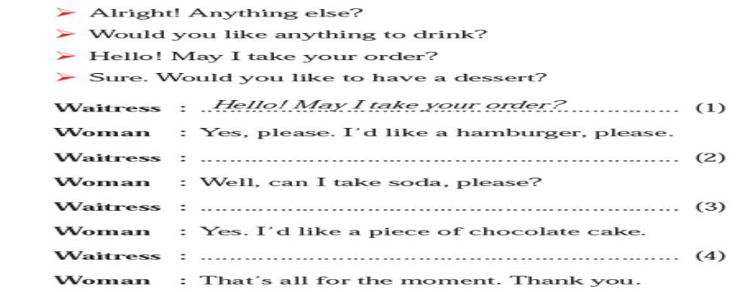

J) PUT THE CONVERSATION IN THE CORRECT ORDER (6 PTS)
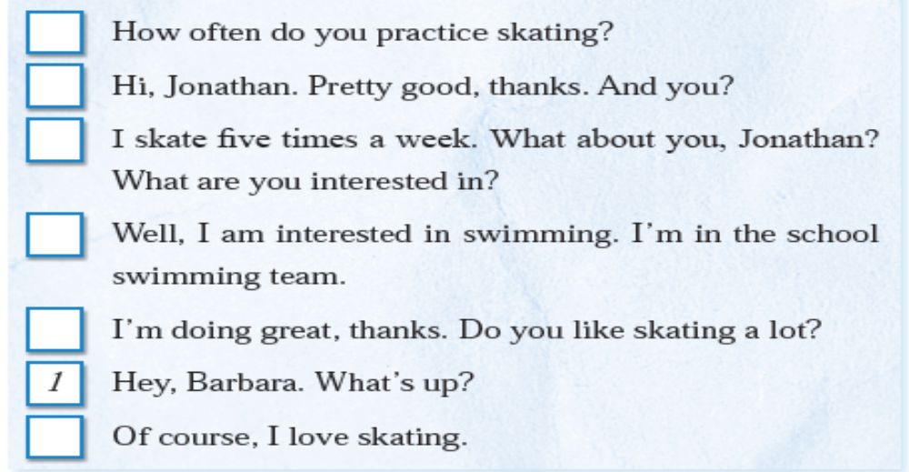
K) CHOOSE THE CORRECT ANSWER (6 PTS)
BONUS
WRITE ABOUT YOUR DAILY ROUTINE

1. Nick: Are you busy tomorrow?
Mel: ---------- . Why?
Nick: We are having a picnic. Would you like to join?

A) I’m sorry B) I’m full
C) No, not at all D) No, thanks.
2.Choose the correct order to complete the card below.

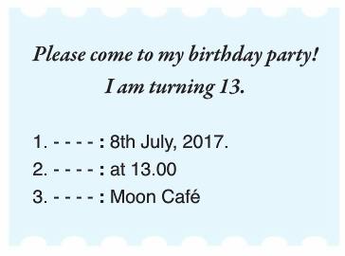

A) place, date, time B) date, time, place
C) time, place, date D) date, place, time
3. ……….I arrive home,I feed the chickens and my dog.
A)why
B)how
C)what
Dwhen

