A) Match the words/ phrases with their explanations. (5x3=15p.)
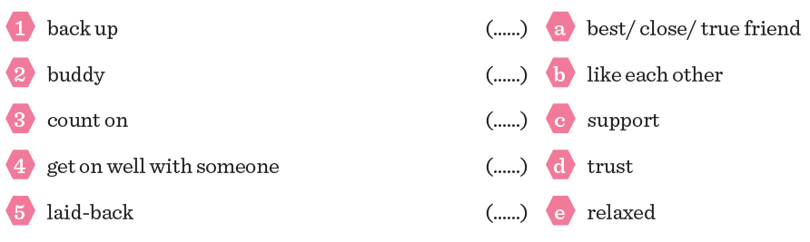
B) Put the sentences into the correct order. (5x3=15p.)
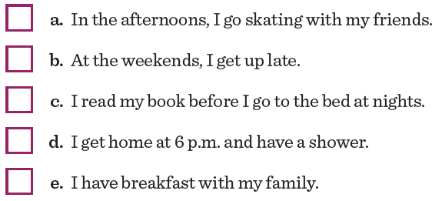

C) Put the words/ phrases into the correct order. (4x4=16p.)

1. eating / you / Do / like / fruit / ?
……………………………………………………………………………………………………………………………
2. bakes / My mother / a cake / sometimes / .
……………………………………………………………………………………………………………………………
3. friends/ argue with / We / in the classroom / don’t / our / .
……………………………………………………………………………………………………………………………
4. come together / twice / They / a year / .
……………………………………………………………………………………………………………………………

D) Match the questions with the correct answers. (6x3=18p.)
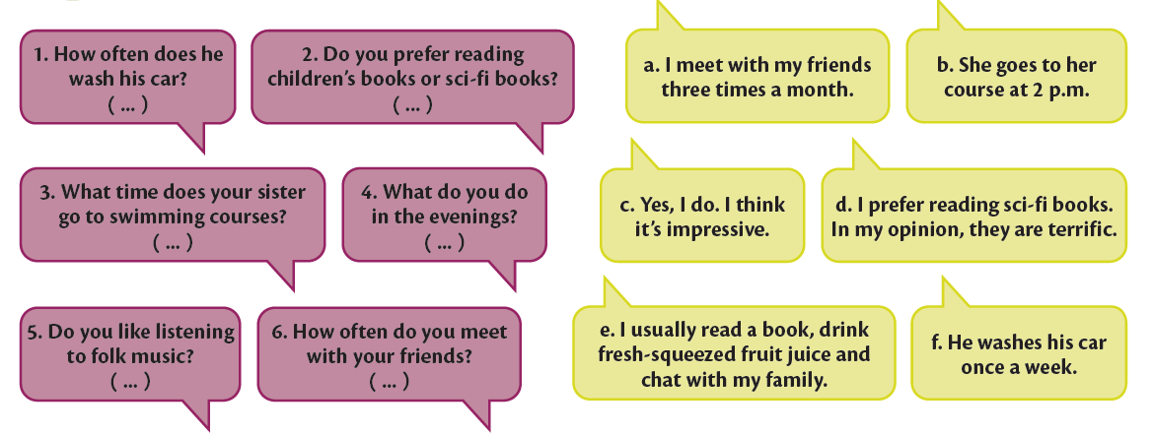

E) Match the words/ phrases with the pictures. (8x3=24p.)
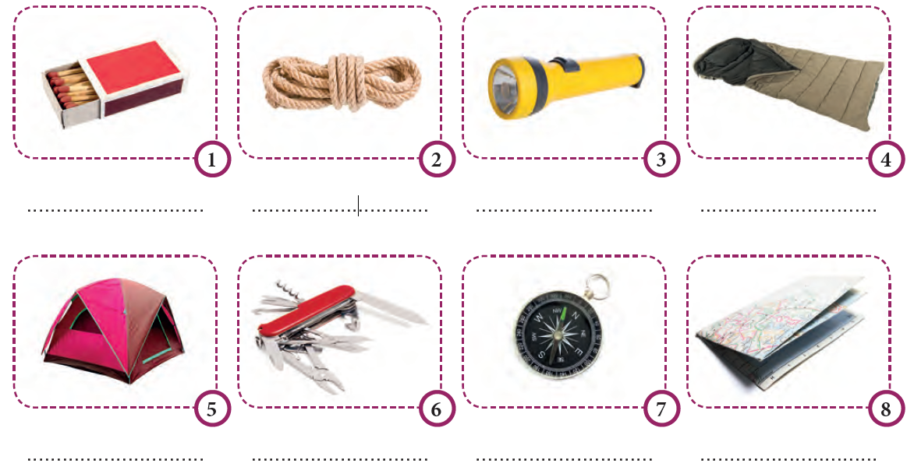
F) Circle the correct words/ phrases. (4x3=12p.)
1 Would you / Shall we like to go to Othello play on Saturday?
2 I’m sorry, but I can’t. / that’s awesome. I have an exam.
3 I’m / I’m not interested in football so I don’t want to come to the match with you.
4 How about go/ going to the shopping mall on Friday?

