Name : Class:5/__
Surname: Number:

A) Match the words with the pictures. (6x3=18 pts)
1) English 2) Physical Education 3) Science 4) Maths 5) Art 6)Music

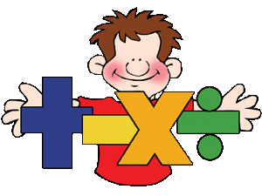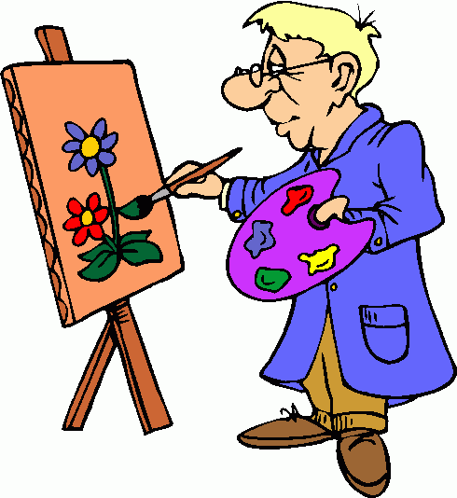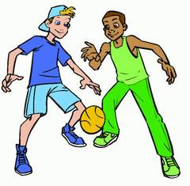
………………………… ………………………… ……………………………… …………………………… ………………………… ……………………….
B: Match the words with their meanings. ( 2 x 10 = 20 pts)
a. hafta sonu
b. cami
c. havuz
d. eczane
e. manav
f. öğrenmek
g. hastane
h. otobüs durağı
i. kırtasiye
j. deney
1. learn (__)
2. experiment (__)
3. weekend (__)
4.stationary (__)
5. bus stop (__)
6. green grocer (__)
7. pool (__)
8. mosque (__)
9. pharmacy (__)
10. hospital (__)

C)Fill in the blanks with the words in the box. (1 x 5 = 15 pts)
on – next to – in front of – in – under - behind

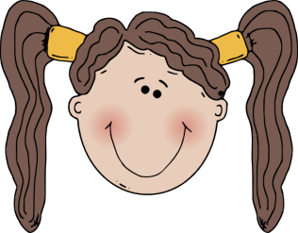
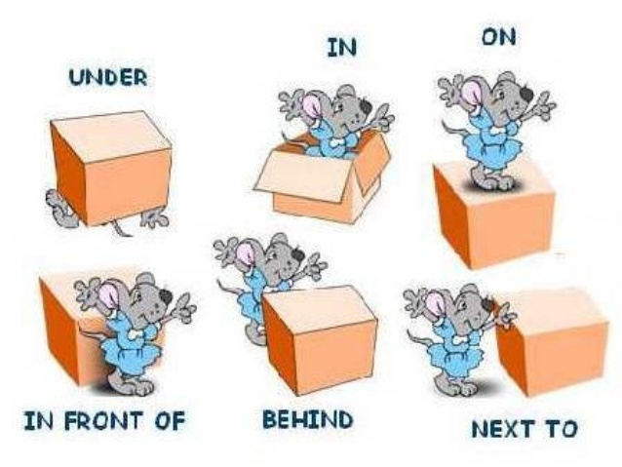

D) Complete the table according to the speech bubble. (8 x 2=16 points)
Name
Age
Country
Nationality
Languages
Favourite lessons
Likes
Dislikes
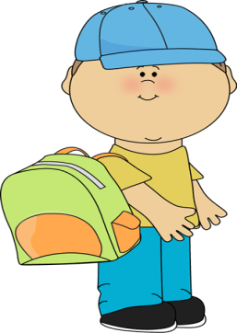
Hello!
My name is Alfred. I am 13 years old. I am from Germany and I am German. I speak English and German languages. My favourite lessons are Music and P.E. He likes Music and P.E. but he doesn’t like Maths class.

E) Match the countries with the nationalities.(3 x 7 = 21 pts)
Country | Nationality
1)Turkey | _____ German
2) Spain | _____ English
3) France | _____ French
4) Germany | _____ Japanese
5) Italy | _____ Spanish
6) England | _____ Italian
7) Japan | _____ Turkish

F) Look at the map and fill in the blanks. (2 x 5 = 10 pts)
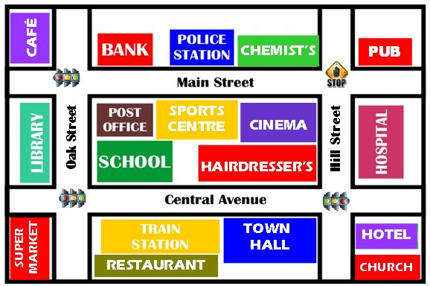
A: Excuse me. How can I go to the police station?
B: Go ________ . Turn _________ . It is on your _______, next to the __________.

You are here.
Recep DEMİROĞLU
English Teacher

