

This boy is helpful and thougtful.
He thinks about others’ needs.
The old woman is short and plump.She is happy .
He likes helping old people.
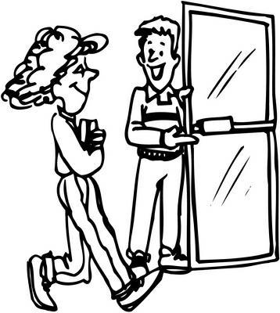
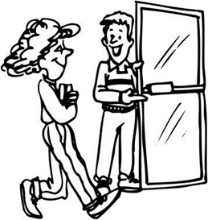
He thinks that people shouldn’t be rude to each other.
He always says ‘’thanks’’ and ‘’please’’.
Can is so polite. He always opens the door for he women.
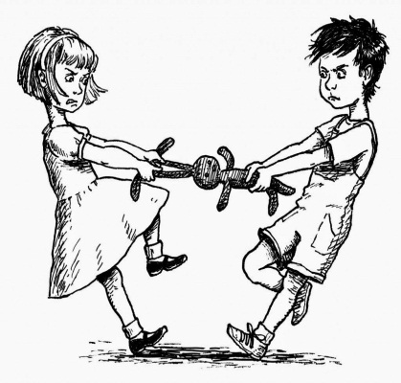
They think only their own needs .They say: Nobody is more important than me!
They never share their toys. So,they generally argue.
They are selfish.


He always gives money to poor people. For him,being a good person is important.
According to him,having a good personality is more important than money.
Sam is short with a big nose.He is generous. He hates stingy people.


He is running.Maybe. he is not a punctual person.But he runs as fast as a cheetah.
He is smiling.He looks happy and funny.He is carrying a bag in his hand.
George is short and fat with a big nose and a wide mouth.


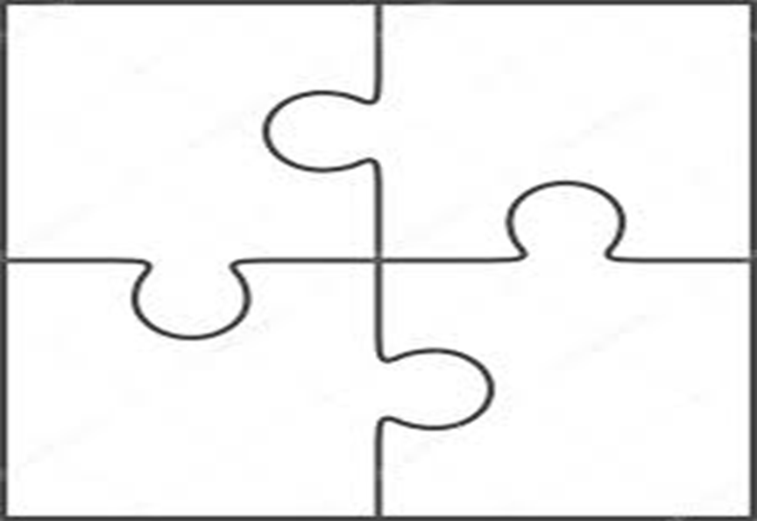
She has only one friend .She thinks being outgoing is very difficult.
She doesn’t like meeting new people.She is shy.
Lisa is a student.She is slim and tall with long wavy hair.

