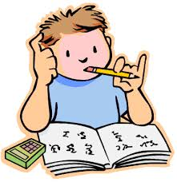
GSD EĞİTİM VAKFI ÇİFTLİKKÖY SECONDARY SCHOOL 2017-2018 EDUCATION YEAR ELECTİVE ENGLISH LESSON 6th CLASS THE SECOND TERM FIRST EXAM QUESTIONS

Name: Surname: Number:

A) Verilen kelimeleri resimlerin altına yerleştirin.(20p)
1-cycle 2- pick flower 3-stay in a tent 4-cook 5-visit museum
6-make a snowman 7-sightseeing tour 8-learn skiing 9-climb mountain 10-play game

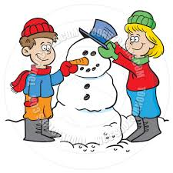
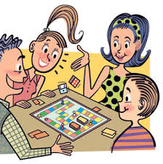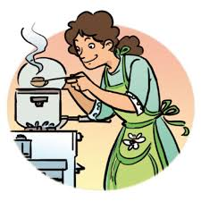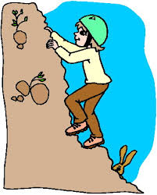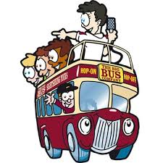

a.__________ b.__________ c._________ d.__________ e.__________
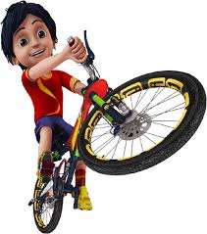
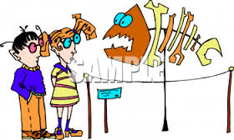 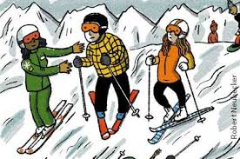 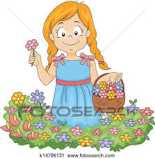 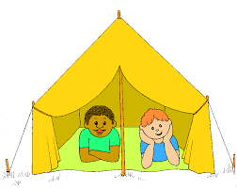f._____________ g._____________ h.______________ ı.______________ j.__________

B)Boşlukları “was – were – wasn’t – weren’t” ile doldurunuz.(16p)

1- Atatürk ............... born in Salonika in 1881.
2- I ................... at school yesterday, because I was ill.
3- Where ...................... you last night?
4- Pelin and Osman ................. at the party on Saturday night.
5- You ..................... at the office an hour ago! You were at the cinema.I saw you there!
6- Today it is sunny, but it .............. sunny yesterday, it was rainy.
7- I think the film ................... very funny. I liked it!
8- I ……………….. very good at swimming last summer. I won alot of medals.

C)Verilen işaretleri anlamalarıyla eşleştiriniz.(14p)

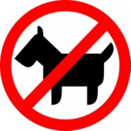
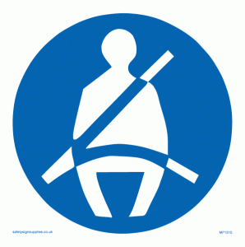


1. Fasten your seat belt.
2. Pets not allowed.
3. Don’t eat or drink.
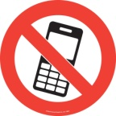
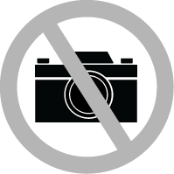

4. For General Audiences.
5. Don’t take photos.
6. No mobile phones.
7. For 13 and over.

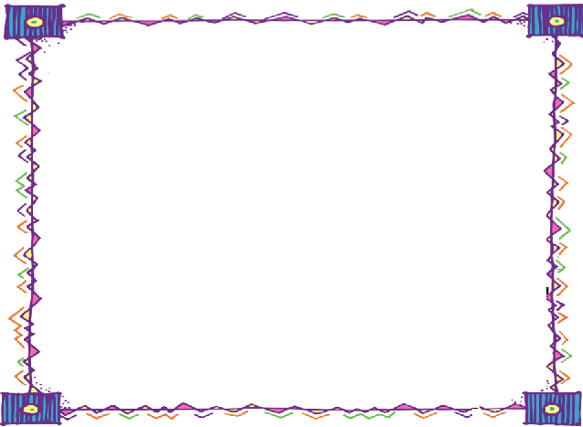
D)Aşağıdaki soruları cevaplarıyla eşleştiriniz.(14p)

a)He visited Eiffel Tower.
b)Yes,I did.
c)Barcelona.
d)Last summer.
e)My mother.
f)No,he didn’t.
g)Because,she lost her doll.
1.Did your brother ride a horse? …………
2.Who made a cake yesterday? …………
3.Where did you go on holiday? …………
4.What did Selim do in Paris? …………
5.Why did she cry an hour ago? …………
6.Did you enjoy at the party? …………
7.When did they take this photo? ………

E)Boşlukları parantez içindeki fiillerin geçmiş haliyle doldurunuz.(16p)

  - We ___________________ play after school yesterday. (play)
  - He ___________________ tv. (watch)
  - My mother ___________________ an omelet. (make)
  - My dad ___________________ home at 8 o’clock yesterday. (come)
  - They ___________________ lunch at home. (have)
  - Dave ___________________ his homework. (do)
  - Students ___________________ lessons last night. (study)
  - We ___________________ swimming last week. (go)
F)Aşağıdaki soruları kendinize göre cevaplayınız.(10p)

1.Where were you born? _________________________________________________________
2.Did you go on holiday last summer? _____________________________________________
3.What do you think about bumper car? _______________________________________________
4.How do you feel getting on a chairoplanes? ____________________________________________
5.Which one is more enjoyable,roller coaster or ferris wheel? _________________________________

G)Diyalogları ''I agree'' ya da '' I disagree'' cümleleriyle doldurunuz.(10p)
1. A:Roller coaster is exciting. 5.A: Tennis is a boring sport.
B:__________________.I think it is thrilling . B:__________________.I think it is amazing

2 .A:Horror films are funny.
B:__________________.They are always frightening.

3.A:Fasten your seat belts in the car.
B:_________________.It saves our lives. GOOD LUCK:)

4.A:Rainy weather is dull.
B:____________________.I don't like rainy days.

