5th Grade 6th Unit Quiz
Name-Surname:

- Write the type of the movie. (7x5=35p)
comedy / horror / sci-fi / animation / drama / romantic / cartoon

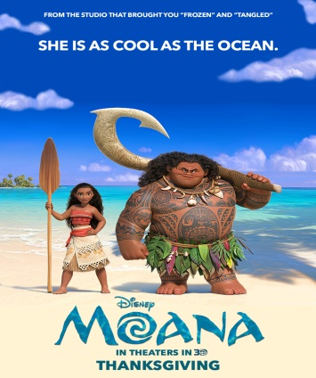


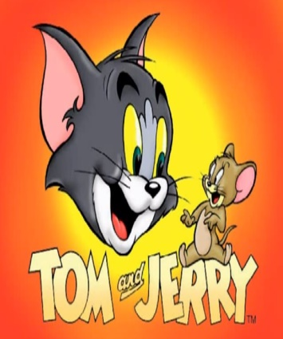

……………….…
……………….…
……………….…
……………….…




……………….…
……………….…
……………….…
- Complete the sentences. (4x5=20p)
exciting / funny / boring / frightening
- I love comedy films, because they’re ………………………………………………………………….
- I hate horror films, because they’re ………………………………………………….……………….
- I llike action films, because they’re …………………………………………………………...……….
- I dislike cartoons, because they’re ………………………………………………………..…………….
- Match the questions with their answers. (5x5=25p)
a) It is “Arif v 216”
b) It is at quarter to three.
c) I think it is funny.
d) It is about two friends.
e) It is a horror movie.

1. ( ____ ) What time is the movie?
2. ( ____ ) What is the film about?
3. ( ____ ) What is your favorite movie?
4. ( ____ ) What type of movie is it?
5. ( ____ ) What do you think about the film?

- Read and complete the chart. (4x5=20p)
My favorite film is Spiderman. It is an action movie. It is about a superhero and his adventures. I think the film is exciting.

Name of the Film | Film Type | About | Opinion



Gizem Yeşiloğlu

