KOLUKISA ANATOLIAN HIGH SCHOOL 2014-2015 ACADEMIC YEAR
2nd TERM FIRST WRITTEN ENGLISH EXAM FOR 11TH GRADES
Name: __________________________ Class: 12 / _____ Number: ________
GRAMMAR (20x2=40 p)
- Complete the sentences with “past simple or past continuous”
- A: What (you, do) __________________ when the accident__________( happen)?
B: I (try) _________________ to change a light bulb that had burnt out.
- When I (walk) ______________ into the busy office, the secretary (talk) ____________ on the phone with a customer, several clerks (work, busily) _______________ at their desks.
- The Titanic (cross) ________________ the Atlantic when it (strike) _________________ an iceberg.
- While I (watch) ________________ a mystery movie on TV, the electricity _______(go) out.
- Complete the sentences with “zero or first conditionals (if)”
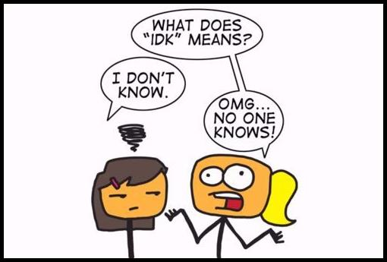
- If you _________(boil) some water, it _______________(evaporate).
- If I __________(study) a lot, I ____________(pass) the exams
- Don’t wait for me if I ________ (be) late to diner
- The lamp________( light) if you________( pres) the button
- Complete the sentences with “possessives”
- He's _____________________ (our/ours) doctor
- Isn't _____________________ (their/theirs) son older than you?
- Your car is green, while _____________________ (my/mine) is black
- I don't know __________ (them/their) very well
- Robert didn't drink his own coffee. He drank _________ (her/hers)
- Complete the following questions with “who what where when how why” (one is extra)
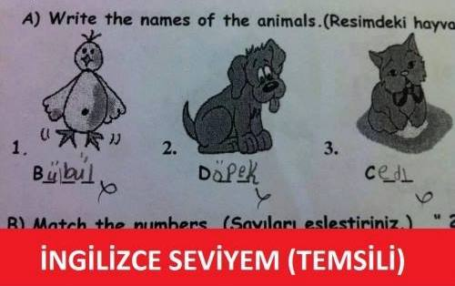
- ____________ do you come to school? I ride my bicycle
- ____________ color is the new bus? Red.
- ____________ is the captain? She is at the gym
- ____________do banks open? - At eight O'clock
- ____________ are you wearing that coat? - Because it's hot!
- Make one sentence from two by using “too or enough”
e.g.: We couldn't eat the food. It was too hot. The food was too hot to eat.
- I can't drink this coffee. It's too hot. This coffee is___________________________________________
- I don't wear this coat in winter. It isn't warm enough. This coat is _______________________________
SPEAKING (4x2=8 p)
Complete the dialogue with the expressions given.
I want to see the manager What exactly is the problem I demand another room can I help you
Receptionist: Good morning,__________________________________?
Complainer : I'd like to make a complaint about the room I’m staying now.
Receptionist : I'm sorry to hear that.___________________________________?
Complainer : First of all the air conditioner isn’t working properly and it‘s too hot inside. Then, the people in the room above sound like they are having all-night parties, every night! So, I can’t have enough sleep.
Receptionist : Oh, I see.
Complainer : ________________________________or my money back!.
Receptionist : I do apologize but I’m afraid all the rooms are full. I'd like to offer you a 20% discount on the price as a gesture of goodwill.
Complainer : A 20% discount, you must be joking! ________________________________!

READING (4x3=12 p)
THE BEATLES
The Beatles were a rock and pop band from Liverpool, England. Formed in 1960, the group primarily consisted of John Lennon (rhythm guitar, vocals), Paul McCartney (bass guitar, vocals), George Harrison (lead guitar, vocals) and Ringo Starr (drums, vocals). The group worked with different musical genres, ranging from rock and roll to psychedelic rock. Their clothes, style and statements made them the most important trendsetters in 1960s. After the band broke up in 1970, all four members started their successful solo careers. The Beatles released more than 40 different singles, albums, and EPs selling over one billion records internationally. Theirs was the greatest commercial success in the history of popular music. In 2004, Rolling Stone magazine ranked the Beatles number one on its list of 100 Greatest Artists of All Time. Their influence on pop culture is still evident today.
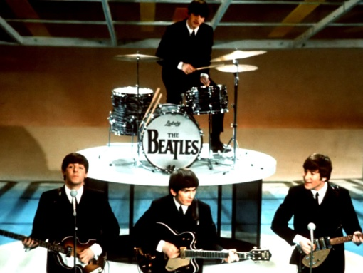
Decide the statements TRUE or FALSE
- Their clothes, style and statements were the most important things ________
- They started the band in 1970 ________
- The group were famous only in Liverpool, England ________
- In 2004, they were selected as number one by a magazine ________

VOCABULARY (6x2=12 p)

Complete Ataturk’s Principles with their Turkish meanings
1. Republicanism : ________________________
2. Secularism : ________________________
3. Populism : ________________________
4. Reformism : ________________________
5. Nationalism : ________________________
6. Statism : ________________________

WRITING (10 p )
Choose one topic and write at least 50 words
- Which one do you like more: summer or winter? Why?
- Problems between parents and their children



Hanifi ARKADAŞ
ELT

