A)Kişilerin bilgilerine göre tabloyu doldurunuz
Murat is from Turkey. He is Turkish. He is eleven years old. He speaks Turkish and German. He likes maths and art.
Elizabeth is from Spain. He is Spanish. She is fourteen years old. She speaks Spanish and French. She likes science.
Pier is from Canada. He is Canadian. He is twenty years old. He speaks English and Chinese. He likes music and P.E.
Tanya is from Russia. She is Russian. She is thirteen years old. She speaks only Russian. She likes history.

 | COUNTRY | NATIONALITY | AGE | LANGUAGES | LIKES
MURAT

ELIZABETH

PIER

TANYA

B)Verilen yer isimlerinin tercümelerini söyleyiniz
bus stop - toy shop - mosque - pool - hospital - bakery - post office

C)Sorularla cevapları eşleştiriniz.
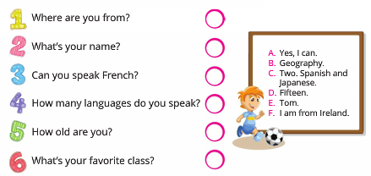
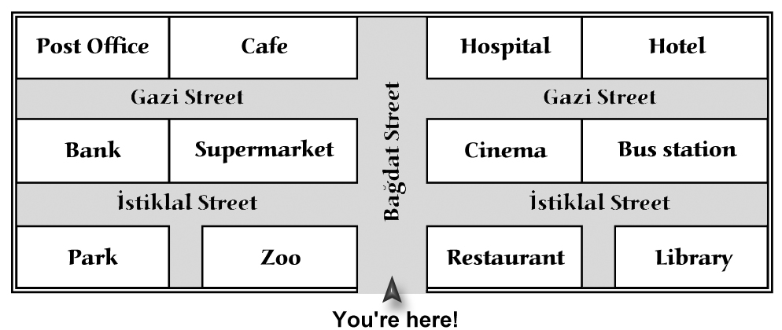
D)Haritaya bakarak tarife göre gitmeniz gereken yer ismini boşluğa yazınız.
- Go straight ahead. Turn left into the Gazi Street. It is next to the café: _____________________

- Go along Bağdat Street.Turn right into the Gazi Street. It is opposite the bus station: _________

- Go along Bağdat Street. Turn left into İstiklal Street. It’s opposite the bank:______________

- Go straight ahead.Turn right into İstiklal Street. It’s next to the cinema:____________________

- Go straight ahead and turn right into Gazi Street. It’s opposite the hospital and next to the bus station. ________________________

E)Boşlukları resme göre verilen kelimelerle doldurunuz.
opposite - between - behind - next to
1.The bus stop is ………………… the school.
2.The toy shop is ………………… the restaurant
and the cinema.
3. The pharmacy is …………………. the library.
4. The police station is ………………… the bank.
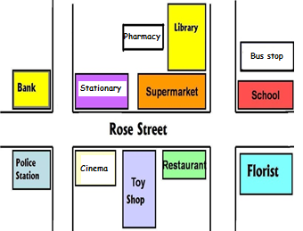

F)Read the text and write TRUE or FALSE. (Parçayı okuyun ve DOĞRU ya da YANLIŞ olduğunu yazın.)
Lola is Spanish. She lives in Spain. She is 13 years old. She is in grade 7. She is in the elementary school. She gets up at 6 o’clock on weekdays. She goes to school by bus. Her school starts at 8 o’clock. On Mondays, she has English class. Lola speaks Spanish but she can’t speak English very well. She learns English at school. She likes Maths most, but she doesn’t like History.

1-Lola is twelve years old. (__________)
2-Lola is from Spain. (__________)
3-She goes to school by bicycle. (__________)
4-She has English on Mondays. (__________)
5- She gets up late on weekdays. (__________)
6-She doesn’t like Maths. (__________)
7-She can’t speak English very well. (__________)

G.Match the countries with nationalities. (Ülkeleri milletler ile eşleştirin.)
1-England | a-Japanese | 1-
2-France | b-German | 2-
3-Germany | c-American | 3-
4-Italy | d-English | 4-
5-Japan | e-Spanish | 5-
6-Spain | f-French | 6-
7-the USA | g-Italian | 7-

H)Fill in the blanks with correct ‘school subject’. (Boşlukları doğru ‘ders’ ile doldurun.)
(Maths – music- PE – science - art

1-We do experiments in ____________ lesson.
2-She is good at playing guitar and piano. Her favourite lesson is _____________.
3-My brother likes drawing pictures. ___________ is his favourite lesson.
4-We solve problems in our _____________ class.
5-My brother is good at football. He loves __________ class.

I)Fill in the blanks with the correct word in the box. (Boşlukları verilen kelimelerle doğru şekilde doldurun.)
between | turn | excuse | welcome | on | straight | left

A:_________me, where is the post office?
B:It is :_________ the Rose Street. Go :_________ ahead. _________ left. It is on your __________. The post office is _________ the supermarket and the bank.
A:Thank you.
B:You’re _________.

