2017-2018 ACADEMIC YEAR ………….. SCHOOL 4th CLASS 2nd TERM 1st
WRITTEN ENGLISH EXAM

NAME | SURNAME | CLASS | NUMBER | POINT

- Aşağıdaki resimlerin altına doğru kelimeleri yazınız. (20 p)

seed - glass - test tubes - pot – bottle - water – goggles - scissors - soil - experiment

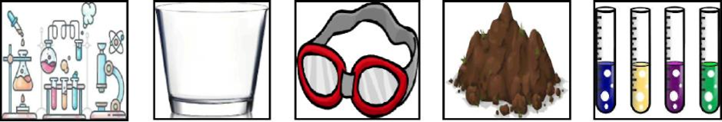

----------------------- --------------------- ----------------------- --------------------- -----------------------
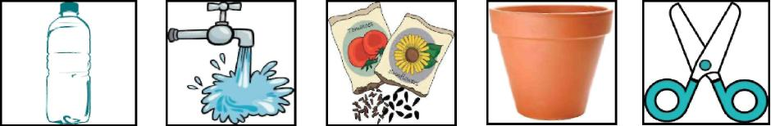

--------------------- ------------------------ ------------------ -------------------- -----------------------

B-) Boşlukları verilen yer zarfları ile tamamlayın. ( 18 p )
in on under next to behind in front of

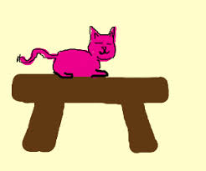  Where is the cat?  It is ………………… the table. | 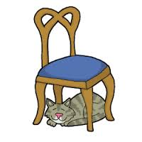  Where is the cat?  It is ………………………… the chair.
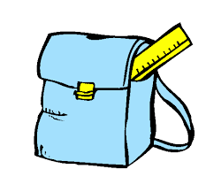  Where is the ruler?  It is …………..….. the school bag. | 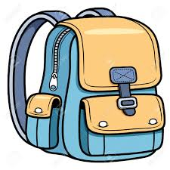  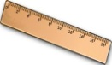  Where is the ruler?  It is ……..……..…..………… the school bag.
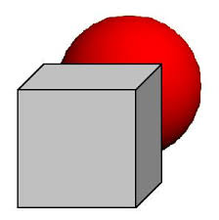  Where is the ball?  It is ………….…………….. the box. | 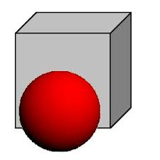  Where is the ball?  It is …………………………………………… the box.

C- ) Saatlerin İngilizcelerini yazın.İngilizce verilenleri de rakamla yazınız.(24 p )

- 04 : 00 It is ………………………………
- 01: 30 It is ………………………………..
- 08 : 15 It is …………………………………
- 02 : 45 It is ………………………………
- 11: 25 It is ………………………………
- ………………… It is twelve oh five.
- …………………. It is six fifty .
- ………………… It is two twenty.

D-) Resimleriyle cümleleri eşleştirin. OK KULLANMAYIN.( 20 P )

- 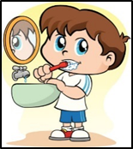 B-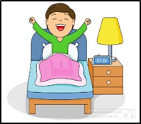 C-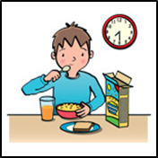 D-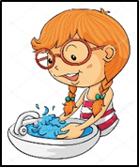 E-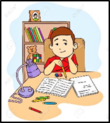 F-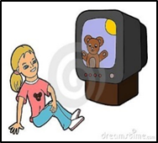

G - 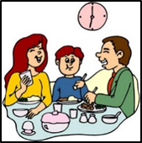 H-  I- 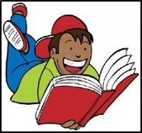 J- 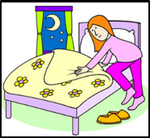

1. I read a book . ___________ 6- I get up early. ___________
2. I have breakfast at seven thirty. ___________ 7- I wash my hands . __________
3. I go to bed at ten o’clock. __________ 8- I do my homework. __________
4. I watch TV in the afternoon. _________ 9- I play computer. __________
5. I brush my teeth. __________ 10- I have dinner with my family._______

E-) Cümleleri okuyup yuvarlaktan bir renk seçerek boşlukları tamamlayın.( 10 p)
1. Mix red and white, you get ____________________.
green
purple orange pink grey
2. Mix yellow and blue, you get _____________________.
3. Mix black and white, you get _____________________.
4. Mix blue and red, you get ______________________.
5. Mix yellow and red, you get _____________________

F-) Kutuların içindeki cümleleri resimlerinin altına yazın. ( 8 p )
I can’t cook. - I can ride a bike. – I can cook . - I can’t ride a bike.

1-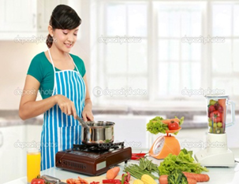 2-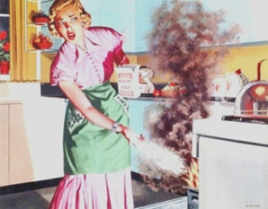 3-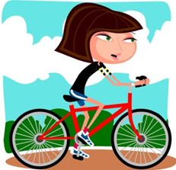 4-

   

