2017-2018 ACADEMIC YEAR ……. SECONDARY SCHOOL 5th GRADE ENGLISH LESSON 1ST TERM 2nd EXAM
Date:01/ 12 /2017
Duration: 40 minutes
NAME :  SURNAME :  NUMBER :  CLASS :5/A | EVALUATION
NAME :  SURNAME :  NUMBER :  CLASS :5/A | EXAM RESULT
A) Fill in the blanks with the verb “To be”.
Yardımcı fiiller ile boşlukları doldurunuz.1p
am –is(2) – are(2)

1. My father _________ at the café.
2. The children _____________ in the cinema.
3. I _____________ slim and tall.
4. Gale and Rita ___________ in the living room.
5. A cat ___________ walking in the street.

B) Circle the correct option. ( Doğru seçeneği işaretleyiniz.)1p

1. Sharon ___________ her teeth everyday.
A) brush B) brushes
C) brushs D) brushies

2. I ___________ have breakfast every Sunday.
A) don’t B) doesn’t
C) do D) does

3. __________ Britney __________ an apple?
A) Do / eat B) Does / eats
C) Do / eats D) Does / eat

4. Does Peter arrive home after school?
………………………. .
A) Yes, I can B) No, he can’t
C) Yes, he does D) No, he don’t

5. Tim ____________ English everyday.
A) study B) studyes
C) studyies D) studies

6. “like – watch – tidy” kelimelerinin
geniş zaman da “-s-es-ies” takılarını almış halleri aşağıdakilerden hangisidir?
A) likes – watches - tidies
B) likes – watchs – tidys
C) likes - watches – tidyies
D) likes – watchs – tidies

7. Do you comb your hair every morning?
...........................................
A) Yes, I can. B) No I can’t
C) Yes, I do D) No, she doesn’t

8. You always ____________ to bed at 10 o’clock.
A) goes B) go
C) goies D) gos

9.10.11. SORULARI TABLOYA GÖRE CEVAPLANDIRINIZ.

 | Get up early | Meet friends | Play chess
JOHN | √√√√√ | √√ | X
MARY | X | √ | √√√
Always: √√√√√ Sometimes: √√
Usually: √√√√ Seldom : √
Often √√√ Never: X

9. How often does JOHN get up early?
…………………………………………..
A) He always gets up early.
B) He seldom gets up early.
C) He never gets up early.
D) He often gets up early.

10. How often does MARY play chess?
……………………………………………….
A) She always plays chess.
B) She never plays chess.
C) She often plays chess.
D) She seldom plays chess.

11. - John always gets up early.
- Mary seldom gets up early.
- John usually meets friends
- Mary seldom meets friends.
Yukarıda verilen cümlelerden kaç tanesi tabloya göre doğrudur?
A) 1 B) 2
C) 3 D) 4

12. Always her zaman
Usually asla
Seldom nadiren
Sometimes bazen
Yukarıda verilen sıklık zarflarından hangisinin anlamı yanlış verilmiştir?
A) always B) sometimes
C) usually D) seldom

C) What time is it? (saatlerin altına doğru seçeneği yazınız.)1p

A) It is five o’clock.
B) It is quarter to four
C) It is quarter past eleven.
D) It is quarter past one.
E) It is half past eight.
F) It is quarter to nine.

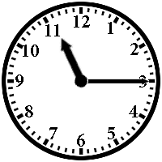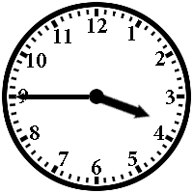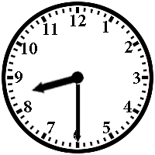

1…………… 2.………….. 3……………..

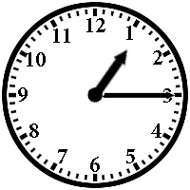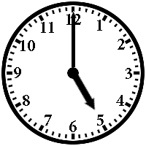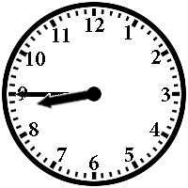

4……………. 5…………… 6………………

D)Draw the given times. (Verilen saatleri çiziniz.)1p
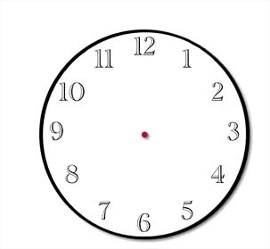

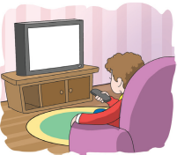

It is ten o’clock. It is half past three.

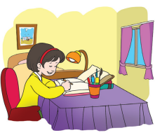

It is quarter past two. It is quarter to seven.

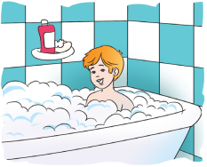

It is five past five. It is ten to four.

E) Can or Can’t. ( resimlere göre boşlukları CAN veya CAN’T ile doldurunuz.)1p

1. 2.


Selim …..……… run. He …………….. swim.
3. 4.

Sharks ……..… swim. Chicken ………dance.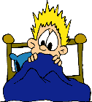
5. 6.


Birds …………. fly. David ………… sleep.

F) Write the daily routines. (Günlük rutinleri yazınız.)1p
A) arrive home B) do homework
C) have a shower D) watch TV
E) have breakfast F) sleep

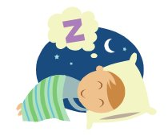
…………………… …………………….
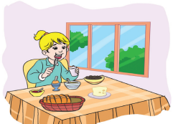

……………………. ……………………
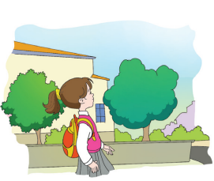

……………………… ……………………..

G) Write the seasons and the months. (Mevsimleri ve ayları yazınız.)1p

SPRING – AUTUMN – WINTER – SUMMER
March – January – August – June – July – February - April – September – December – October – November - May



…………………… ………………….
1-………………… 1-…………………..
2-………………… 2-…………………..
3-………………… 3-…………………..

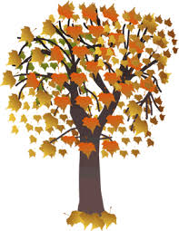
…………………… ………………….
1-………………… 1-…………………..
2-………………… 2-…………………..
3-………………… 3-…………………..

H) Read the passage and write TRUE or FALSE.
(Parçayı okuyup cümlelere TRUE veya FALSE yazınız.)1p

Emre gets up at 7 o’clock. Then, he has breakfast at 8 o’clock. After that, he goes to school at 9 o’clock He has lunch at 12.30. He leaves school at 3 o’clock. He arrives home at 4.30.

- Emre gets up at 07:30. (……..…)
- Emre doesn’t have breakfast. (……..…)
- Emre goes to school at 10 o’clock. (……..…)
- Emre has lunch at 12:30. (……..…)
- Emre arrives home at 04:30. (……..…)

I) Choose the correct option. (Sorulara uygun cevapları işaretleyiniz.) 1p

1. Where do you live?
A) I love Ankara
B) I live in Ankara
C) Yes, I’m
D) No, I don’t.

2. What time do you go to school?
A) Ayşe
B) at 8 o’clock
C) in İstanbul
D) I’m fine

3. Which school do you study?
A) I study at Atatürk Secondary School
B) Yes, I do
C) I do homework
D) No, I can’t

4. Can Yeliz ride a bike?
A) Yes, she can
B) Yes, she does
C) No, she doesn’t
D) No, she can.

5. Does Cindy watch Tv everyday?
A) No, she can’t
B) No, she doesn’t
C) Yes, she can’t
D) Yes, she doesn’t

6. Who combs hair every morning?
A) in the cinema
B) Peter
C) do housework
D) Yes, it is

7. How often does Bob brush his teeth?
A) always
B) at 7 o’clock
C) swim
D) No, he doesn’t

8. When does Esra feed the birds?
A) No, she doesn’t
B) in the morning
C) in the garden
D) Yes, she does

J) Fill in the blanks according to the given picture.(Verilen resme göre boşlukları doldurunuz.) 1p

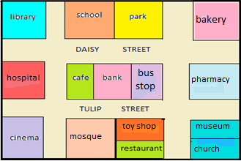
between - behind - next to - opposite - in front of

1. The bakery is ______________the pharmacy.
2. The school is _________________ the park.
3. The bank is _________________ the cafe and the bus stop.
4.The restaurant is ________________ toy shop. 5. The museum is ___________________ the church.

K) Circle the correct one. ( Doğru olan seçeneği yuvarlak içine alınız.) 1p

1. My mother sleep / sleeps early every evening.
2. We watch /watches television in the evenings
3. They do / does do their homework.
4. Ali and Elif play / plays tennis on Sundays.
5. Ebru study / studies English everyday

WRITING (10p)
Talk about your daily routines.
(Günlük rutinleriniz ile ilgili en az 5 cümlelik bir paragraf yazınız.)

………………………………………………………………………………………………………………………………………………………………………………………………………………………………………………………………………………………………………………………………………………………………………………………………………………………………………………………………………………………………

LISTENING (10p)
Listen and choose the correct option.

Ted gets up at 6.30 – 7.30. He has breakfast at 7 o’clock. He has lunch – goes to school at 8 o’clock. His classes start –finish at half past eight.
He has lunch at school at half past eleven –
half past twelve. After school, he plays football with his friends.

