2016-2017 ACADEMIC YEAR ………… SCHOOL 1ST TERM 2nd ENGLISH WRITTEN EXAM FOR 7TH GRADES

NAME : NUMBER:
SURNAME : CLASS: PUANI :


- Parçaya göre aşağıdaki ifadelere TRUE (doğru) ya da FALSE yazınız.(5.3=15P)
I’m Jonathan. I am seventeen years old. I am crazy about scuba diving. I started scuba diving seven years ago. I have training four times a week.


She is Sue. She doesn’t like volleyball or basketball. Actually,she can’t stand team sports. She likes roller blading and ice-skating. She also goes swimming three times a week and she sometimes rides a horse.
He is Mike. He likes sports, too.He is in the basketball team of our school. He always has training on weekdays. He plays table tennis at weekends.
1. Jonathan has training for times a week. (……………….)
2. Mike has training at weekends. (……………….)
3. Sue sometimes rides a horse. (……………….)
4. Mike plays volleyball at weekends. (……………….)
5. Sue likes individual sports. (……………….)

- Soruları cevapları ile eşleştiriniz.(5.3=15P)

1. How often does İrem go gymnastic training? (……) Mehmet.
2. Who goes jogging everyday? (……) She is tall and slim.
3. What did you do last night? (……) Three times a week
4. What does “nil” mean? (……) I watched TV.
5. What does Melike look like? (……) Zero.

C . Verilen kelimelerin türkçe anlamlarını karşılarına yazınız.(5.2=10p)

- Snake a)……………………..
- Tiger b)……………………..
- Lion c)……………………..
- Monkey d)…………………….
- Crocodile e)…………………….

D. Write the names of the sports. (1O.3=30P)
baseball -- cycling -- sailing -- parachuting – swimming
horse riding -- rollerblading -- skiing -- dancing -- volleyball

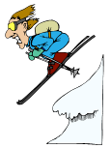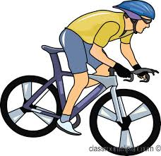
....................... ....................... ....................... ....................... .......................
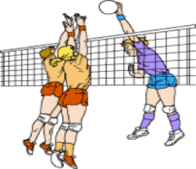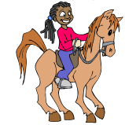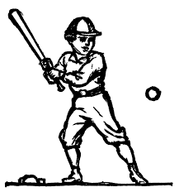
....................... ....................... ....................... ....................... .......................

E. Present Simple or Present Continuous. (10.3=30P)

1. Look! Pierre ……………………………………………… the flowers. (water)
2. Listen! The girls ………………………………………… a song. (sing)
3. She usually ……………………………………………… home by bus. (come)
4. Jean ………………………………….……… to his grandmother every day. (go)
5. Look! Sam and Joel ………………………………..……………… tennis. (play)
6. Nicky ………………………………………… a cup of tea every morning. (drink)
7. We can’t play tennis. It …………………………………… now. (rain)
8. Bill ………………………….……………… his homework at the moment. (do)
9. Jane always …………………….…………………… her homework in her room. (do)
10. The boys sometimes …………………………………..………… to the park. (run)
...................................................................................................................................................... .
GOOD LUCK

