2015-2016 ACADEMIC YEAR ……. SCHOOL
2nd TERM 2nd WRITTEN ENGLISH EXAM for 5th CLASSES
Name, Surname: Grade:
Class:
Number:
A) Match the words with the pictures. (Aşağıdaki resimleri uygun kelimelerle eşleştiriniz.)

A) candles
B) party hats
C) gift
D) doll
E) invitation card
F) drinks
G) cake



B) Circle the correct choice. (Doğru seçeneği daire içine alınız.)
1- You must / mustn’t brush teeth.
2- We must / mustn’t wash hands and face.
3- Sally must / mustn’t drink cola. It is not healthy.
4- I must / mustn’t run in the classroom.
5- We must / mustn’t do homework.

C) Complete the dialogue. (Diyaloğu kutucuktaki ifadelerle tamamlayınız)

Why don't --- Let's --- What about --- Shall we

Akın: __________________ go to the cinema? There is a good film on at the cinema.
Ceren: I'm really tired and I want to stay at home. ______________ we buy a DVD and watch it at home?
Akın: That sounds good. ______________ buying a horror film?
Ceren: I don't like horror films.
Akın: OK. ______________ buy a comedy film.
Ceren: Great! I love comedies.


YOU’RE INVITED TO MY BIRTHDAY!


Come to my birthday party on April 15, at 5:30 P.M. It’s at my house. The address is Malatya Street, No: 34 (it is next to the supermarket). I want some CDs and party games. Bye!
Diane

D) Yukarıdaki doğum günü davetine bakarak aşağıdaki cümleler doğruysa “True”, yanlışsa “False” seçeneğini işaretleyiniz.
1. It is Diane’s birthday party. TRUE FALSE
2. The party is at a café. TRUE FALSE
3. Her house is next to a bookshop. TRUE FALSE
4. She wants some party games from her guests. TRUE FALSE
5. Her party is at half past six. TRUE FALSE
E) Resimlere bakarak kutucukta yer alan aktiviteleri numaralandırılmış boşluklara yazınız.

run --- do weightlifting --- roller skate --- swim --- windsurf --- climb --- go cycling --- play football --- go skating --- play tennis

Hello! My name is Alice. Everybody in my family can do different activities. My father can (1)_____________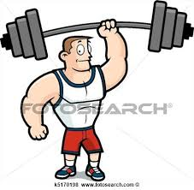and (2)______________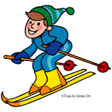but he can't (3)____________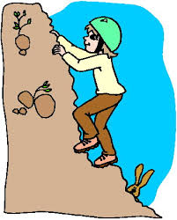. My mother can (4) _______________ 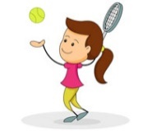 but she can't (5) _______________ 
My brother can (6) ___________but he can't (7) _____________  or (8) ______________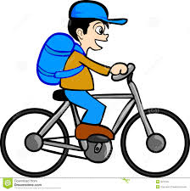 . I can (9) ________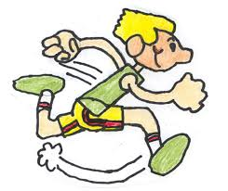fast but I can't (10) ______________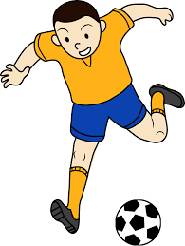

F) E kısmındaki “can ve can’t” cümlelerine bakarak aşağıdaki kutucukları fiillerle doldurunuz.
 | Can | Can't
Alice
Alice's father
Alice's mother
Alice's brother

